**RAYLEIGH METHODIST CHURCH**

Eastwood Road

Rayleigh

**Minister**

Rev. Phil Warrey 01268 770333

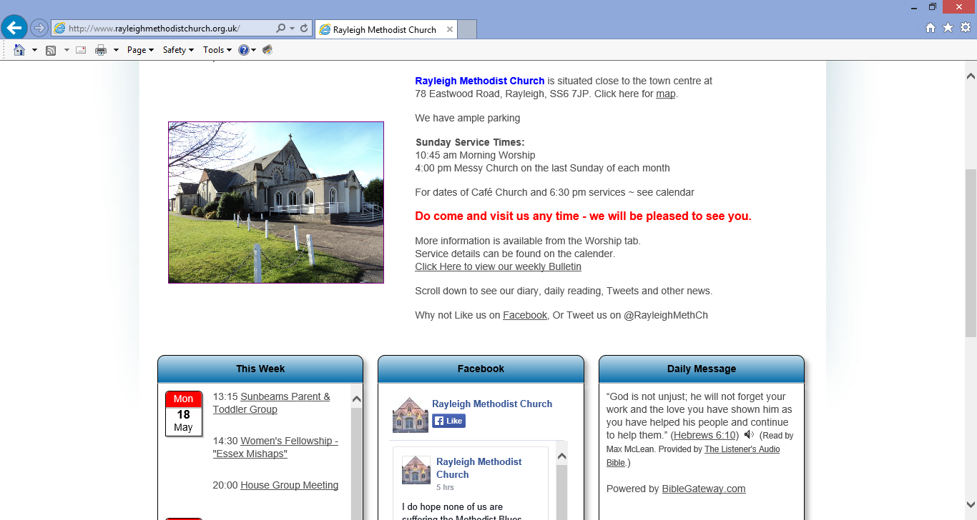

**THE NEWSLETTER**

**JUNE 2016**

**1**

**Leaving Well – Dealing with change**

A few weeks ago we had to rush out a letter, following some rumours that we were leaving this summer. I am sorry that we had to drop the bomb shell on you so quickly, but we felt we did not want the rumours to spread, and we wanted you all to know that we were planning to go into stationing and leave well in August 2017, when my current station comes to an end. We would have so much preferred to tell you gently, and in our own time. Thank you all for your patience and understanding. Change is not easy.

Some of you will have noticed that I have a new car. No doubt, there will have been comments: “How much are we paying our ministers now……..?”. My Touran had got to the stage where it was beyond economical repair, so it had to go. We decided that when Caroline’s car had to be changed, that we would move over to leased cars, so our expenditure was more controllable, and not to have the excitement of huge bills every time something went wrong! Which seemed to be happening more often than not. So this year, I had the excitement of my very first new car, a shiny Red (bottom of the range) Polo. When I went to pick it up, it was all wrapped up, and it had a huge red bow on it! I do still miss my Touran though.

As I sit down to write this I come from having just packed my bag. We are going off this weekend to Nottingham for our youngest daughter’s wedding. More change! It only seems like last month we were still dealing with her tantrums. (Yes, now when I come to think about it, that was last month…..)

All these things have made me reflect on change. We are facing a lot of change at the moment, grandchild, weddings, new car, and a move in 2017.

If I look back to the last time I bought a car, I was facing change then. In 2008, I’d just been promoted to Chief Electrical Engineer, and this new position, and new responsibilities was more than I’d ever hoped for. We took this as an opportunity to buy a newer car, and bought one 18 months old, the newest car we’d ever owned. A seven seater mini mpv, so we could still take our kids, and a few others to school. Little was I to know what was coming!

In 2009, our American bosses decided to close down the UK office, and move everything to Pittsburgh. Did we want to go and live in Pittsburgh? No! It was quite a shock to us all. After all, we had a full order book, we’d made a £1m profit the year before. We’d even been recruiting new staff the very month before. But the USA office had run out of work, and they wanted our global work. In particular, our Chinese orders. (We were selling things into China!)

There was nothing we could do to stop them. I did my bit, I was on the “Works Committee”, and fought hard, but to no avail with our American bosses to keep us open – I thought that that would be the Methodist thing, the Christian thing to do. We achieved 2 things, one was to get full redundancy paid to those who found jobs, and left, and secondly we got a minimum amount agreed even for those who had only just started. You may have noticed; I don’t give in easily.

**2**

So in 2009, facing redundancy, I signed up for a course at Wesley College, Bristol. Somehow, that led to candidating, and the path to becoming a Methodist Presbyter started. (I’d already been a LP since 1989).

Change was dramatic throughout 2009, it was hard to keep pace with. People were leaving and finding new jobs fast. Some found better positions and more money than we’d been able to give them. At one point I had to bring in sub-contractors to finish work for projects the Americans could not cope with. I kept telling them they could not do without us! So in September 2009, long after I was due to be made redundant, I was doing the day job, and being a student.

On 31st December 2009, I was officially made redundant, we’d handed the office keys back to the landlord early December, and I’d been doing the last bits of work from home. I sent the last batch of designs to Iran on my last day. Switched off the computer and that was the end. 1st Week of January, a phone call, “Phil can you help us”…… This led to me working for them 1, 2, 3, days a week, then full time all through my training. This all helped put food on the table for the family, as I studied. It seemed that the Lord had a plan!

The Americans could not cope with the Chinese, so off I went; and thank goodness for laptops and the internet, as I found myself writing theological essays in my Chinese hotel room and submitting them just in time.

Then came more change, Wesley College was being closed around my ears, and they would not let me do my last year of training there. I thought it was going to be a disaster, but no, God had a plan, and I ended up being “Student Minister” in Midsomer Norton. (The same circuit Rev Elizabeth is going to in September). That was a fantastic time, I could do no wrong! They’d had a curtailment, and thought they’d have to go without a minister for a year, and they got me! I did my last year of training with Sarum College. (But still sneaked up to Wesley College while it was still open).

Then the big committees met, and decided we would be coming to Essex and Southend and Leigh. What? All the way over there? The other side of London! It was quite a shock, and even more so for Caroline who had all her life lived in a one-mile radius around Bristol.

But we arrived, and you made us welcome, and we were a big change for you. We made you do different things, and try different things, and there was a bit of resistance (and still is! – There will be a microwave and a fridge in Rayleigh’s kitchen, before I leave even if it kills me!). But we’ve started some good new things together, and together laid some things to rest. We’ve grown to love each other, warts an’ all.

Caroline has blossomed since we have been here, new challenges, new job(s). Made new friends. Started singing in a choir. (Even some solos). Become a Church Steward. Even started training as a Worship Leader.

So what a huge change we have faced in our lives since 2008, new life, new vocation, a move, daughters married off, grand child born, and new cars! I even

**3**

managed to get a proper degree with “Honours”! Would we want to have changed anything – probably not.

Sometimes although we resist change and don’t want things to change, good things, new things, new ideas can arise out of change. Change keeps us on our toes, change keeps us alive.

Many people have come up to us, and said that they will be sorry to see us go, and we thank you for that. We need to face up to and embrace this change, all of us. It will be hard for us to leave you too.

But think, you will have a new minister, with different experiences, new ideas, all to help you grow and move closer to the kingdom.

We are still with you for another year and a bit, and in that time we need to:-

1. Consolidate and strengthen the things we have started together, so they are sustainable. (In Rayleigh this is especially important to make sure our “Big Project” is either kicked off and started before we go, or in a good well documented position for the team to carry forward with out us)
2. Look at what changes need to be made in our churches, and what you would want a new minister to do. (This needs to go into the new minister profile).
3. Carry on with what we are doing day by day.
4. Keep praying for each other, as we go through the stationing process.

In my next magazine article, I will write some more about the stationing process, on how the system works to find a new minister for you, and how we are found a new station.

In the meantime, let’s not dwell too much on the change, or the future, but just get on with things, and see where the Lord takes us, and try and follow God’s plans for us. Whatever that may be!

**Every blessing Phil**

**MESSAGE OF THANKS**

Thank you for your prayers for my recent time in hospital, and for the beautiful flowers and cards.  They certainly aided my recovery.  I am pleased to say I am out and about once again.

Many thanks

Judith Ring

**4**

**CHURCH FAMILY NEWS**

Congratulations to Amy and Perry Ridge on the birth of a daughter, Alice Jane, on 26th April - a first grandchild for Fiona and Neil Othen and a  greatgranddaughter for Roy and Marjorie Miatt.  
  
Best wishes also to Jim and Val Smith on the arrival of a new granddaughter, Caitlin, born on 12th May to Andrew and Carla.  
  
Loving sympathy goes to Evelyn Long and her family  following the death of her sister Joyce, and also to Margaret Rider and her family on the death of her brother.  Margaret is recovering from an injured pelvis, which sounds very painful.  
  
Loving thoughts and prayers are also with Christine Vincent following the death of her sister.

At present Joan Wortham is in residential care in Westcliff.  Please remember her in your prayers.  
  
Please let me know if there is any special news, or anniversaries coming up.  A steward will always pass on a message.

Val Tyler

**WOMENS FELLOWSHIP**

Our programme for June is:

6th   Speaker -  Jenny Wilson

        Magnets for Life

13th  Members Afternoon--

         with raffle

20th   T.B.A.

27th   Speaker - Ann McLaren

          "Tales of Vicky the Camper Van

 Elaine Blades

**5**

**THANKS**

Many thanks for the lovely flowers delivered by Val. I am pleased to report that I am now making good progress following my fall and am much more mobile thanks to the efforts of the Physio. Hoping to see you all again soon.

Margaret Rider

**WESLEY GUILD**.

I would like to thank all members who took part in, and all long suffering souls who supported our Medical Missions evening oon Saturday 23 April; the sum of £515 was raised in aid of the Nigeria Health Care Project.

The NHCP is an initiative of the (National) Wesley Guild and is currently acting to support and improve primary health care at 14 different centres in rural areas of Nigeria. One important activity is the teaching of local Nigerians to train others in the resuscitation and care of new born babies.

In a country where more than 250,000 new born babies die every year, this is a very worth while operation.

We have two coffee evenings arranged as follows:

9 June 8pm. At the home of Don and Margaret Babbage,

                                         21, Philbrick Crescent East, Rayleigh.

23 June 8pm. At the home of Irene Calver,

                                           69, Daws Heath Road, Rayleigh.

Finally, a word of thanks to those members who made cakes for our coffee evening on 12 May; wehad more than enough and hope the Scouts enjoyed the "left overs"

Pat Oatley.

**6**

WORSHIP ACADEMY AND WESLEY’S CHAPEL.

Vibrant! That was, in one word, my summary of our visit.

Phil arranged for 30 of us from Worship Academy to have a study day out, and what a wonderfully inspiring d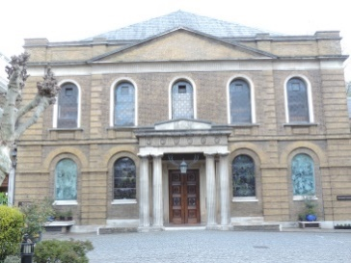ay it turned out to be. Not a lot of study, but plenty to think about.

On arrival we received a warm welcome from The Rev the Lord Leslie Griffiths, and had a refreshing cuppa.

We then watched a DVD, before Leslie gave a very interesting and informative talk about the founding of the “Society of the people called Methodist”. The talk was illuminated with many anecdotes, and with his usual dry sense of humour. He explained how the past has impacted on the present and future, and what a wond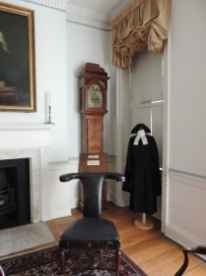erfully rich heritage of spirituality, service and social awareness we have.

We then divided into two groups to tour the Chapel, the Foundry Chapel, House and Wesley’s grave.

W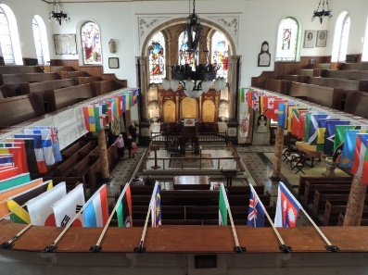esley’s Chapel is full of colour and items of interest. The flags hanging from the balcony represent the nationalities of church members. 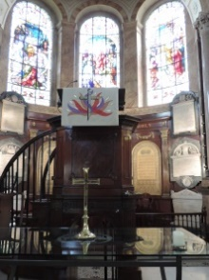

The beautiful stained and engraved windows. The two tier Pulpit (it used to be three). The little shelf seats that extend from the end of the pews.

One of the most emotive objects was contained within the marble Font; the remains of one used to baptise slaves. Some of us, being brave, then ventured up onto the balcony where we got a wonderful overview of the Chapel. We could also get close to, and even touch some of the lovely windows.

**7**

The overwhelming feeling, which was almost tangible, was of the years of prayer and worship that these walls are soaked in.

Our Guide then took us outside to see John Wesley’s grave, a striking monument in a little garden, in the midst of modern buildings and the hustle bustle and noise of the East End.

We then went into the Foundry Chapel, a relic from John’s early beginnings in the East End. When that first building was demolished, most of the fixtures and fittings were transferred to the new one. Obviously the old bench pews were made for smaller posteriors than modern Methodists with a higher degree of tolerance for discomfort!

We were then taken into Wesley’s House, which an Estate Agent would describe as a “Bijou” residence, functional and appropriate for John’s position and needs. The ground floor contained the kitchen etc. the first floor was his living quarters, with a small prayer room leading out of the bedroom. An item of furniture of great interest was a strange chair that John used as an armchair, or study chair if used back to front! It even had a fixed writing ledge on the back, and a drawer under the seat for paper supplies.

The top floor of the house was reserved for the use of visiting preachers and their families. Very handy!

After lunch we had a talk by Jennifer Potter about hymn singing, and John Wesley’s “rules for singing”. The early Methodists tended to chant their words as per the Anglican custom, but as a wandering preacher, out and about in the highways and byways, they began to use folk tunes familiar to the local, often illiterate, people. However, John being a prodigious writer of hymns, and his brother Charles an accomplished musician, the tradition of rich and scriptural Methodist hymn singing began.

At the end of our time together we shared in a service of Holy Communion, in the Foundry Chapel, presided over by Jennifer and Leslie.

There was just time for a quick cuppa before heading home.

Thanks to Kirby’s for a safe journey there and back. Thanks to Phil for organising such an interesting trip. Thank you Jennifer and Leslie for your warm welcome and informative talks, and to all the staff at City Road. Thanks to John and Charles Wesley, for our wonderful heritage. Most of all praise to our loving gracious God for; “Love divine all loves excelling, joy of heaven to earth come down, fix in us thy humble dwelling, all thy faithful mercies crown”. ***Janet Warner.***

**8**

**SMILING IS INFECTIOUS,**

You catch it like flu,

When someone smiled at me today,

I started smiling too.

I walked around the corner

And someone saw me grin,

When he smiled I realised

I had passed it on to him.

I thought about the smile

And then realised its worth,

A single smile like mine

Could travel round the earth.

So if you feel a smile begin,

Don't leave it undetected,

Start an epidemic

And get the world infected.

**SUNNY SUNDAY AFTERNOON – 26TH JUNE 3PM**

On Sunday 26th June all are invited to an event at Rayleigh Methodist Church called Sunny Sunday Afternoon. Please bring your deck chairs, and your knotted handkerchiefs, for a lovely sunny afternoon in the field.

We will be having games on the field, croquet, and rounder’s. (Hopefully as Christ Church URC Rayleigh are joining us, we can field a team and beat them in our first Methodist vs URC Rounder’s tournament).

We shall also have:-

•Bouncy Castle (we are trying to get an uprated one so we can have an adults session).

•Scones, Cream, Jam and Cakes.

•Messy Crafts

•Puppets

•A short worship service with Music from the URC Worship Band.

•We may even have some songs around the camp fire.

Please look out for the posters, and requests to help make cakes, and scones, and some sandwiches.

If you have any other ideas that would make the afternoon go even better, please let Phil know.

**9**

**COFFEE MORNING**

**18 JUNE 2016 10am-12noon**

**for**

**MYAWARE**

(June and Les)

**It will include the following stalls, cakes cards, books, bric-a-brac,**

**and many more**

**All welcome, please come along and support us**

*Many thanks goes those who supported the Christian Aid coffee morning when £200.55 was raised*

**HELP FROM GOD**

A woman found herself in trouble. Her business had gone bust and she's in serious financial trouble. She is so desperate that she decides to ask God for help. She begins to pray.. “God, please help me win the lottery! I've lost my business and if I don't get some money, I'm going to lose my house as well. Please let me win the lottery.

Lottery night comes and somebody wins it.

Edna again prays... “God, please help me win the lottery! I've lost my business, my house and I'm going to lose my car as well.

Lottery night comes and Edna has no luck.

Once again she prays... “My God why have you forsaken me? I've lost my business, my house and my car. My children are starving. I don't often ask you for help and I have always been a good servant to you. PLEASE just let me win the lottery this one time so I can get my life back in order”.

Suddenly there is this blinding flash of light as the heavens open and Edna is confronted by the voice of God himself.

“Edna meet me halfway on this. “Buy a ticket!”

* + - 1. **10**

**FINANCE AND PROPERTY REPORT**

This is an update of the situation as at early May.

Average weekly offerings for the present financial year are £710 per week. However our Circuit Assessment is £818 per week and this is expected to increase to almost £850 in August.

Fortunately lettings are going very well and we should get a higher Gift Aid tax payment than previous years, partly because of having two Gift Days in one tax year.

The Car Park has been refurbished and eventually enough was raised from the Gift Day, donations and fund raising to cover the initial cost. We then decided to complete the job which cost an additional £2200. After paying for this there is £5400 left in the Maintenance Fund. Unfortunately two of the four gas heaters in the Church were condemned and are in the process of being replaced , they cost about £2000 each! We still need to re-line the entire car park at a cost of about £600 and hope to do this during the June half-term week.

As you may have already gathered we need to fund raise to cover costs.

Please see the articles in the June Newsletter under “High Society” and “Afternoon Cream Teas” and how else can **YOU** help to improve our finances?

**Pat & John Harrison**

**HIGH SOCIETY**

On Saturday 17th December we have a coach trip to the Mill at Sonning to see the Cole Porter musical “High Society”

We have a few seats left the cost is £63 for lunch at the Mill, best seats in the theatre, coach and drivers tip including a contribution to the church building fund.

If you would like to join us please see me or phone on 01268 774637

John Harrison

**AFTERNOON CREAM TEA**

On Saturday 13th August from 2pm to 4pm we are having an afternoon tea on the lines of last years event. The cost is £5 and the profit will go towards the building fund.

Please book the date and bring your friends.

**Margaret Flintham & Pat Harrison**

1. **11**
2. **SERVICES FOR JUNE**
3. **[S] = Sacrament of Holy Communion [P] = Parade**
4. **[B] = Infant Baptism**
5. 5 June

8:30 am [S]

Rev Clifford Newman

10:45 am MORNING WORSHIP

* + - 1. Jane Fulford

1. 12 June 10.45 am  MORNING WORSHIP [P]  
          Rev Phil Warrey
2. 4:00 pm  CAFE CHURCH

Rev Phil Warrey

* + 1. 19 June 10.45am MORNING WORSHIP

Val Windsor

1. 26 June 10:45 am MORNING WORSHIP

Rev Chris Reeve

* + - 1. 4:00 pm Messy Church (CHURCH SECTION)

Rev Phil Warrey

* + - 1. 3 July 10:45 am MORNING WORSHIP
      2. Mrs Julie Caddick

**THANKS**

On behalf of my sister Jill, brother Andy and myself, I thank all my friends for their sympathy cards and flowers sent to us on the passing of our mum (Evelyn Cross). Phil gave two wonderful services at the crematorium and back here at the Methodist Church, where we also enjoyed the wake meal with our relations and friends. It was greatly appreciated by us all.

Pam Armstrong and family

**12**

1. **RAYLEIGH METHODIST CHURCH**
2. **PRAYER GROUP MEETING DATES**
3. 
4. **2016:**
5. June: 1st, 15th & 29th
6. July: 13th & 27th
7. August: 10th & 24th
8. September: 7th & 21st
9. October: 5th & 19th
10. November: 2nd, 16th & 30th
11. December: 14th & 28th
12. ***ALL MEETINGS ARE ON***
13. ***WEDNESDAYS, COMMENCING***
14. ***AT 9.30AM, FOR ABOUT 45MINS.***
15. **FROM THE EDITORS WE NEED YOUR ARTICLES**
16. **Combined July / August 2016 EDITION**
17. *The deadline for this edition of the Newsletter is Sunday 12 June 2016 ( in Welcome Area) or Wednesday 15 June (through our letter box or by email).*
18. [***johnward816@gmail.com***](mailto:johnward816@gmail.com)

**BIBLE STUDY**

There are no meetings during July and August

**Clifford**

**LADIES CLUB**

1 June - half term

8 June - Margaret Butler - Canada

15 June - Gavin Dixon  -  Fishermen's Mission

22 June - Strawberry Tea - 2pm (all welcome)

29 June - Maz Morgan

6 July - Spot The Onto

13 July - Summer Lunch

20 July - Who are you!

**Elizabeth Ellis**

**SERVICES**

**Sunday Services**  10:45 am

Café Church 4:00 pm on the 2nd Sunday of each month

Messy Church 4:00 pm on last Sunday of each month

also occasional services at 6:30 pm.

See church noticeboard for this month’s details

**Junior Church**  10:45 am

**Monthly Mid-Week Communion** (except in August)

On the 3rd Tuesday of the month in the WESLEY ROOM at 10:30 am.

**REGULAR WEEKLY MEETINGS**

**Monday**

1:15pm Sunbeams Parent and Toddler Group

2:30 pm Women's Fellowship

**Wednesday**

1:45pm – 3:15pm Ladies Club

4:15 pm-5:30 pm Rainbows

5:45 pm -7:15 pm Brownie Guides

7:00 pm-8.45pm Guides

**Thursday**

10:00 am Care and Share

5.15 pm- 6.15pm Beavers

6:30 pm - 7:45 pm Cubs

8:00 pm – 9:30pm Scouts

8:00 pm Wesley Guild (Sept to May only)

**Friday**

4:30 pm-5:45 pm Rainbows

5:30 pm-7:00 pm Brownie Guides

7:15 pm -9:00 pm Guides

7:15 pm -9:00 pm Guides Senior Section (fortnightly)



**Preschool**

Mon 9:15 am to 11:45 am

Tues Weds Thurs Friday 9:15-11:45 am & 12:30-3:00 pm

*Editors John and Sue Ward* 9 *Sheridan Close Rayleigh SS6 8YR Telephone 01268* 742847 **(johnward816@gmail.com)**