**RAYLEIGH METHODIST CHURCH**

Eastwood Road

Rayleigh

**Minister**

Rev. Phil Warrey 01268 770333

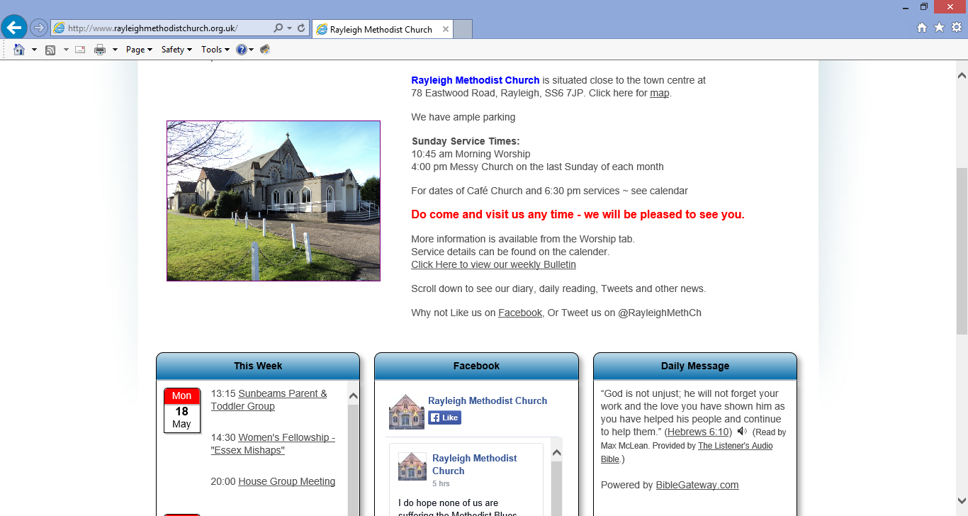

**THE NEWSLETTER**

**JULY / AUGUST 2016**

**1**

**Dear Friends …..**

As I write this article, we have not yet had the referendum on Europe, so I cannot comment on the actual outcome. I have tried my best to not influence your decisions, but as I write this I am planning to vote to remain, as I believe we are better off together, and are in a better position to influence change from within than from without.

Again as I write this article, it is in the week following the death of the MP Jo Cox and the death of 50 (or more) LGBTQI people in Orlando. We have all been saddened by this, and it has given us all a wakeup call against the rhetoric of hate that comes from the mouths of some politicians, some of our media, and some of our church leaders.

This last week, I have been on a media course at St John’s College in Durham, and it has been most challenging to see how the media, mediates the stories it tells, and puts their own spin on the stories, how one or two well-chosen words can influence our thoughts say on people on welfare or those who don’t pay a fair share of taxes. Who are the real scroungers?

The media in not telling us some stories, or staying quiet about some stories also influences us. We were not told of the Islamic Relief Fund that send workers to the floods in Cumbria, we were not told of the Muslims who demonstrated in London last week to say that the killing of the LGBTQI people in Orlando was not in their name.

The reading last week was of Legion, and how he was possessed by many demons. I reflected on these demons in my sermon on Sunday, how we demonise people and situations, and how loud the “noise” of the media, and the rhetoric of hate for different sides surrounds us, and nags at what we do, and what we believe.

The church has been complicit in denouncing and condemning people over the centuries, and now we must turn to Christ and see what he does.

Jesus speaks of love and peace. Just before he met Legion, he stilled the loud and violent storm on the lake, with just a few words. “Peace, be still”. Into the situation with Legion he speaks words of calm, calls out the demons and speaks love and peace.

**2**

Let us constantly look for the truth. Let us not allow people or situations to be demonised, let us look for the good. Let us like Christ, speak the words of peace and love.

Whatever happens in the referendum, let us do whatever we can and whatever is in our power to try and build a better future for those who will come after us, and let us work to build Christ’s kingdom.

Every Blessing

Phil

Ps A big thank you to everyone who has expressed their sorrow about us leaving in August 2017. Thank you for your kind words, and words of encouragement. Remember, we are still with you for another year, and let’s see what we can do, and how we can maximise our efforts in kingdom building in that time.

Also a thank you for your kind wishes to Jessica and Michael on their Wedding Day. We all had a wonderful time, and she was stunning in her Dress, and they will make a wonderful couple.

**August Worship on the Move**

Our last experimental Worship on the Move is on Sunday 14th August at 4pm. Please can you let me know if you would like to host this, otherwise we can hold it at the manse. Worship on the move was trying to be an opportunity to bring worship to those who can’t normally get to worship on a Sunday. This has not quite worked as we had hoped, but we have had some lovely fellowship in people’s homes. You just need to be able to seat about 10 people and provide a cuppa and a biscuit, we will do the rest.

**Open Manse – Saturday 6th August**

The manse will be open from 2pm to 6pm on the 6th August for a Cream Tea, all are welcome.

 Regards,

Phil

**3**

1. **SERVICES FOR JUNLY and August**
2. **[S] = Sacrament of Holy Communion [P] = Parade**
3. **[B] = Infant Baptism**
   * + 1. 3 July 10:45 am MORNING WORSHIP
       2. Mrs Julie Caddick
4. 4:00 pm  BAKE OFF CHALLENGE
   * 1. CAFE CHURCH Rev Phil Warrey
5. 10 July 10.45 am  MORNING WORSHIP [S]  
          Rev Phil Warrey
   * 1. 17 July 10.45am MORNING WORSHIP

Local Arrangement

1. 24 July 10:45 am MORNING WORSHIP

Roger Thomas

* + - 1. 6:30 pm EVENING WORSHIP
      2. Rev Phil Warrey [S]
      3. 31 July 10:45 am MORNING WORSHIP
      4. Rev Clifford Newman

4:00 pm Messy Church

Rev Phil Warrey

* + - 1. 7 August 10:45 am MORNING WORSHIP [S]
      2. Rev Phil Warrey

1. 14 August 10.45 am  MORNING WORSHIP  
          Pamela Smith
2. 4:00 pm  WORSHIP ON THE MOVE

Rev Phil Warrey

* + 1. 21 August 10.45am MORNING WORSHIP

Andrew Thomas

1. 28 August 10:45 am MORNING WORSHIP

Local Arrangement



**4**

**CHURCH FAMILY NEWS**

Congratulations and best wishes to John and Elaine Blades on the occasion of their Diamond Wedding Anniversary on July 7th.  
  
Birthday greetings and loving thoughts go to Gwen Courchee for her 98th birthday  on 23rd June and also to Joan Wortham, who  reached 96 recently. Both are in residential care but still a part of the church family.  
  
Jean Farrance has a new grandson with the birth on 12thJune of Leon Fox Harmon to Claire and Rob. Best wishes to all the family.  
  
Loving sympathy is sent to the family of Pam Clatworthy, a long-time member of this church, who died recently.  John Lorrimore used to visit her frequently in her Basildon care home.  
  
Betty Stubbington and her family wish to thank everyone for of condolence, cards and prayers following the tragic death of her son-in-law Richard. These were a comfort and much appreciated.  
  
Sheila Allen is making a good recovery from her hip operation and we look forward to seeing her soon.

Val Tyler

**WOMEN'S FELLOWSHIP**

Our programme for July is as follows:

4 July Social afternoon

11 July  Speaker - Joan Williams - Trip to Australia

18 July  July Lunch 1 o/clock start

         plus raffle

         Entertainment "It Takes Two"

We restart the meeting on 5th September at 2.30p.m.

Elaine Blades

**5**

**THANKS**

Many thanks for the lovely flowers delivered by Val. I am pleased to report that I am now making good progress following my fall and am much more mobile thanks to the efforts of the Physio. Hoping to see you all again soon.

Margaret Rider

**WESLEY GUILD**

Coffee Evenings / Afternoons have been arranged as follows:

7 July 8:00 pm

at John and Pat Harrison

8 Warren Close, Rayleigh

21 July 8:00 pm

at Rene Crompton

14 Gayleighs, Rayleigh

4 August **3:00 pm**

at Nina Garrett

38 Thorrington Avenue

Dawes Heath, Thundersley

18 August **3:00 pm**

at Joan Watts

28 Brooklyn Drive, Rayleigh

1 September 8:00 pm

at Rev Phil and Caroline Warrey

259 Eastwood Road, Rayleigh

Grateful thanks are due to all those who host our arternoon and evening 'Get-Togethers' during the Summer months.

Our regular 8:00 pm thursday meetings at the church resume on 15 September 2016.

All are welcome!

Pat Oatley

**6**

**6th Rayleigh Sea Scout Group**

This year is the 100 years anniversary of Cubs.

Our Cubs spent the weekend of the 10-12th of June camping at the local Scout Camp site at Belchamps in Hawkwell, together with 800 other Cubs from Crouch Valley District and other Districts in South East Essex. They were able to experience lots of new activities over the weekend and even the weather did not deter them enjoying themselves. The Cubs from 6th Rayleigh were asked what were their favourite, and least favourite activities over the weekend and here are some of their comments;

My favourite in Cub Camp was quad biking,

My favourite was driving a JCB

My favourite was Archery

My favourite was going on high ropes and the wobbly ladder

My favourite was doing a cluedo trail at night

My favourite was making a rope

My favourite was being altogether and all the activities

My favourite activity was caving

I really liked the activities and the delicious food

With very few exceptions their least favourite was the difficulty in sleeping and one Cub said the worst bit was the rain. But they were all pleased to see Rev Phil who joined them for a meal on Saturday night and helped some of them with some craft activities.

We are very grateful to the Church for allowing us to dry our tents in the Church.

The next big event is the Essex International Jamboree for which we are still fund raising. We hope that as many people as possible will come and support the Scout Group on Saturday the 9th July between 10am and 12pm when we are holding a Coffee morning together with a Car Wash and a number of stalls.

**7**

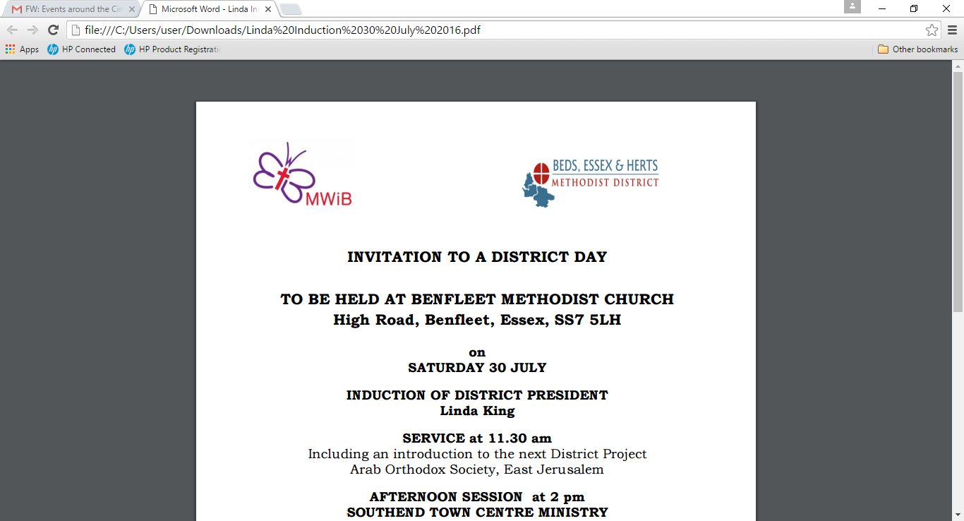

**INVITATION TO A DISTRICT DAY**

**TO BE HELD AT BENFLEET METHODIST CHURCH**

**High Road, Benfleet, Essex, SS7 5LH**

**on**

**SATURDAY 30 JULY**

**INDUCTION OF DISTRICT PRESIDENT**

**Linda King**

**SERVICE at 11.30 am**

Including an introduction to the next District Project

Arab Orthodox Society, East Jerusalem

**AFTERNOON SESSION at 2 pm**

**SOUTHEND TOWN CENTRE MINISTRY**

**Revd Hannah Bucke**

Coffee available at Benfleet’s regular coffee morning from 10 am

Lunch 1pm – 2pm

Please bring packed lunch, drinks available

Tea and Ca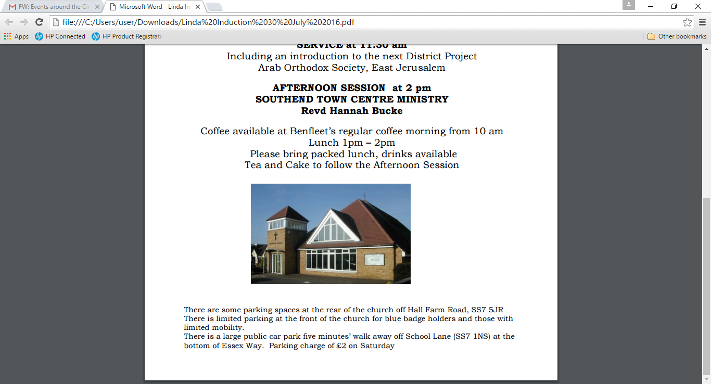ke to follow the Afternoon Session

There are some parking spaces at the rear of the church off Hall Farm Road, SS7 5JR There is limited parking at the front of the church for blue badge holders and those with limited mobility. There is a large public car park five minutes’ walk away off School Lane (SS7 1NS) at the bottom of Essex Way. Parking charge of £2 on Saturday

**8**



**CONCERT**

COME AND HAVE A FISH AND CHIPS MEAL

SONGS FROM 1955 TO 1965

2 JULY 2016 START 6:30 PM

at

Hadleigh Methodist Church

Tickets £10:00

Contact 01702 551786

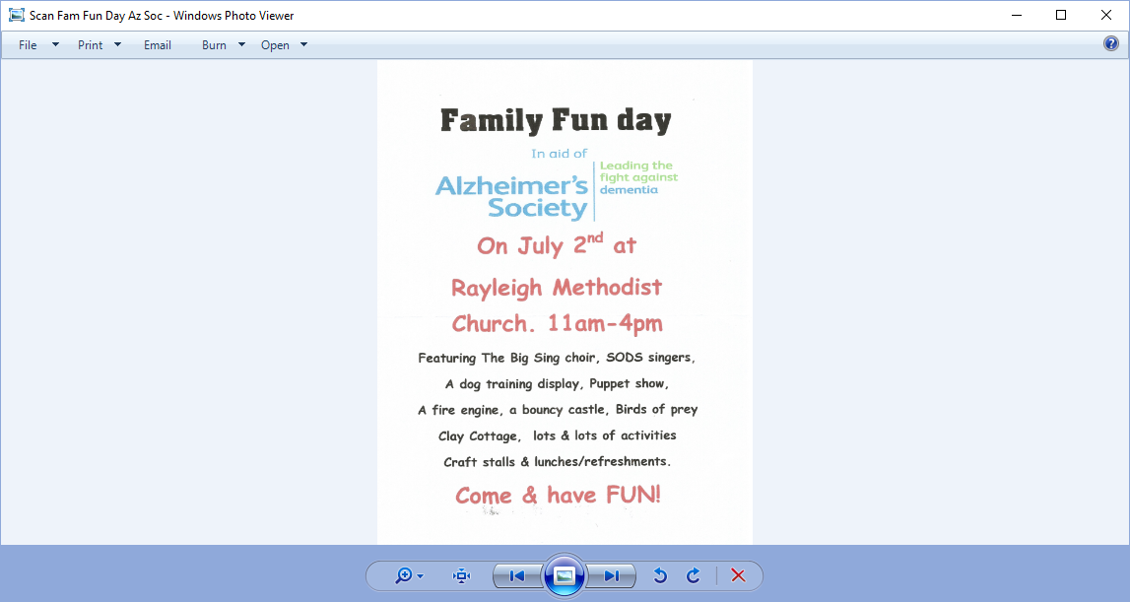

**9**

**Hi Friends,**

I hope you don't mind this email as I'm after a favour – which is a bit cheeky of me I know!

During 23rd and 24th July  I'll be attempting the Oxfam Trailwalker Challenge

This involves walking 100km in 30 hours, across the South Downs - so I'll probably kill myself in the process!

I'm undertaking it in a team of 4 - Martin (a cub leader from Rayleigh), a Scouter from Thurrock and his mate.

I must be mad, as I understand that Trailwalker has grown out of the Ghurkas passing out challenge, where they had to complete 100k fully loaded (albeit in a shorter time and in the heat)

So how can you help?

It would really give my tired and achey old legs a major boost to know was being sponsored - especially as the money goes to Oxfam

We've set up a just giving page ..

[https://www.justgiving.com/fundraising/Hobgoblins](https://www.justgiving.com/fundraising/Hobgoblins#_blank)

Please click through and sponsor us, I've sent this email out quite late, so hopefully you'll do it today rather than putting it off like I often do!

Oh and ps... please forward to anyone else who you feel might possible have a spare penny or 2 to help out

Thanks for reading

Paul Chapman

***Songs of Praise* want to visit you**

The BBC TV programme Songs of Praise is looking for churches and individuals to help them share the story of faith in the UK. If you're interested, or know of a church or person who might be, why not get in touch with the [Methodist Media Office](mailto:mediaoffice@methodistchurch.org.uk?subject=Songs%20of%20Praise#_blank) after reading [more information here](http://methodist-news.org.uk/BVI-4A54B-IW4VFM-2561AP-1/c.aspx#_blank)?

**10**

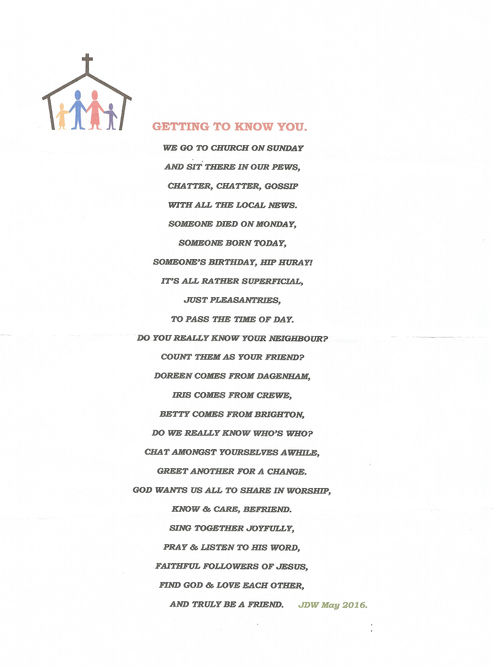

**GETTING TO KNOW YOU**

WE GO TO CHURCH ON SUNDAY

AND SIT THERE IN OUR PEWS,

CHATTER, CHATTER, GOSSIP

WITH ALL THE LOCAL NEWS.

SOMEONE DIED ON MONDAY,

SOMEONE BORN TODAY,

SOMEONE'S BIRTHDAY, HIP HIP HOORAY!

IT'S ALL RATHER SUPERFICIAL,

JUST PLEASANTRIES,

TO PASS THE TIME OF DAY.

DO YOU REALLY KNOW YOUR NEIGHBOUR?

COUNT THEM AS YOUR FRIEND?

DOREEN COMES FROM DAGENHAM,

IRIS FROM CREWE,

BETTY COMES FROM BRIGHTON,

DO WE REALLY KNOW WHO'S WHO?

CHAT AMONGST YOURSELEVES A WHILE,

GREET ANOTHER FOR A CHANGE.

GOD WANTS US ALL TO SHARE WORSHIP,

KNOW AND CARE, BEFRIEND.

SING TOGETHER JOYFULLY,

PRAY AND LISTED TO HIS WORD,

FAITHFUL FOLLOWERS OF JESUS,

FIND GOD AND LOVE EACH OTHER,

AND TRULY BE A FRIEND.

JANET WARNER (MAY 2016)

**11**

**Smile Lines**

**Notices that didn’t quite ‘make it’…**

The preacher for Sunday next will be found hanging on the notice board in the porch. Churchyard maintenance is becoming increasingly difficult, so it will be appreciated if parishioners cut the grass around their own graves.

**Baptism**

The vicar announced that an additional font would soon be placed in the church, so that babies could be baptised at both ends.

**Vote carried**

The vicar was ill in hospital and so the churchwarden went to visit. Trying to cheer him up, the churchwarden said: ‘We missed you at PCC last night. We even put forward a resolution to wish you a speedy recovery. It was passed by 14 votes to 12.’

**Getting ready**

Two children watched their grandmother reading her Bible. ‘Why does she do that?’ whispered one. ‘I expect she’s studying for her final exams,’ came the reply.

**Life choice**

A small boy returned from Sunday School in tears. When questioned by his mother for the reason of his distress, he gulped: ‘Jesus wants me for a sunbeam, but I want to be an engine driver.’

**It’s cool**

I was at summer scout camp where the final service was to be taken by a bishop. It was a very hot, humid day and the clergy from local churches were slowly melting in their various heavy robes. Finally one snapped: ‘When is that flipping bishop going to turn up? ‘ Whereupon a man close by, dressed in Scouts shirt, tie and short trousers, said mildly: ‘I’m already here.’

**No worries**

A 102 year-old lady was asked if she had any worries about the future, and replied: “Not since I got my eldest son into an old people’s home.’

**Vatican**

Once asked how many people worked in the Vatican, Pope John XXIII replied: “Oh, about half.”

**Open wide**

A lady was very nervous about her appointment at the dentist. She sought courage from her Bible. The verse her finger landed on was Psalm 81:10: ‘Open thy mouth wide and I will fill it.’

**What exactly is ‘a lie’?**

A little boy was asked in a school exam to explain what ‘lying’ is. He wrote: ‘A lie is an abomination unto the Lord, but a very present help in trouble.’

**Come in**

The choir was practising the anthem. The choirmaster said to the trebles: ‘Now don’t forget, when the tenors reach ‘The Gates of Hell’, you come in.’

**12**

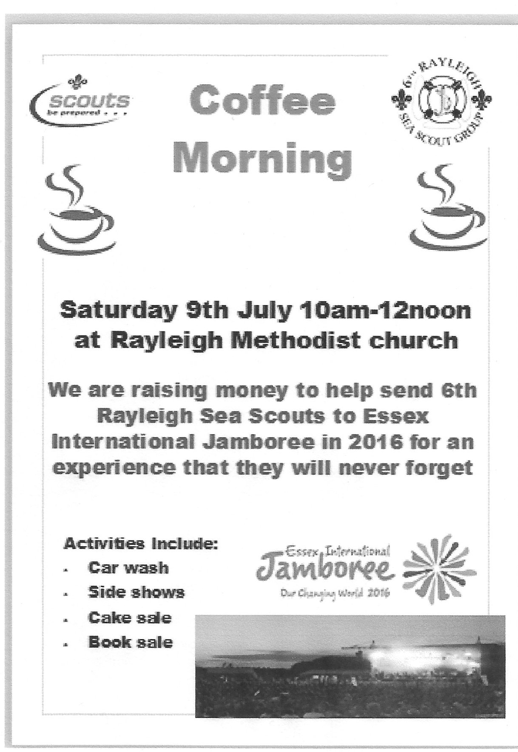

**13**

**COFFEE MORNING**

**20 August 2016 10am-12noon**

**for**

**CHURCH FUNS**

(Marion Dann and Sheila Cooper}

**It will include the following stalls, cakes cards, books, bric-a-brac,**

**and many more**

**All welcome, please come along and support us**

*Your continued support is much appreciated*

**15JULY ST. SWITHUN (OR SWITHIN) - SAINT FOR A RAINY DAY**

St. Swithun is apparently the saint you can blame for rainy summers. It is said that if it rains on his special day, 15th July, it will then rain for 40 days after that. It all began when Swithun was made Bishop of Winchester in 852 by King Ethelwulf of Wessex. It was an important posting: Winchester was the capital of Wessex, and during the 10 years Swithun was there, Wessex became the most important kingdom of England.

During his life, instead of washing out people’s summer holidays, and damping down their spirits, Swithun seems to have done a lot of good. He was famous for his charitable gifts and for his energy in getting churches built. When he was dying in 862, he asked that he be buried in the cemetery of the Old Minster, just outside the west door.

If he had been left there in peace, who knows how many rainy summers the English may have been spared over the last 1000 years. But, no, it was decided to move Swithun. By now, the 960s, Winchester had become the first monastic cathedral chapter in England, and the newly installed monks wanted Swithun in the cathedral with them. So finally, on 15 July 971, his bones were dug up and Swithun was translated into the cathedral.

That same day many people claimed to have had miraculous cures. Certainly everyone got wet, for the heavens opened. The unusually heavy rain that day, and on the days following, was attributed to the power of St Swithun. Swithun was moved again in 1093, into the new Winchester cathedral. His shrine was a popular place of pilgrimage throughout the middle ages. The shrine was destroyed during the Reformation, and restored in 1962. There are 58 ancient dedications to Swithun in England.

* + - 1. **14**

**METHODIST ECUMENICAL OFFICE OPENED IN ROME**

Pope Francis and senior Methodist representatives from around the world recently welcomed the opening of the Methodist Ecumenical Office in Rome (MEOR).

The MEOR initiative will aim to promotes greater understanding of the worldwide communion through education programmes, and the welcome it can offer from its location just across the River Tiber from St Peter's Basilica.   More details at: [www.methodist.org.uk/news-and-events](http://www.methodist.org.uk/news-and-events)

**Preachers told: content over comedy, please**

A recent survey by Christian Research of 1800 church-goers has discovered that almost nine out of 10 of us (88 per cent) disagree or strongly disagree that the idea of a sermon being preached in church each week is outdated.

But when asked what they wanted to see most in a sermon, men in particular (49 per cent) most wanted to hear biblical exposition (women 39 per cent). Women wanted to hear even more practical application (44 per cent) than men (36 per cent). A sense of humour is only perceived as important by two per cent and personal anecdotes by one per cent.

The age of the rambling sermon is over, too. The most common sermon lasts between 10 and 20 minutes (44 per cent). Only 15 per cent of sermons last more than 30 minutes and only one in 10 think a sermon should last any longer than that.

**HIGH SOCIETY**

On Saturday 17th December we have a coach trip to the Mill at Sonning to see the Cole Porter musical “High Society”

We have a few seats left the cost is £63 for lunch at the Mill, best seats in the theatre, coach and drivers tip including a contribution to the church building fund.

If you would like to join us please see me or phone on 01268 774637

John Harrison

**AFTERNOON CREAM TEA**

On Saturday 13th August from 2pm to 4pm we are having an afternoon tea on the lines of last years event. The cost is £5 and the profit will go towards the building fund.

Please book the date and bring your friends.

Margaret Flintham & Pat Harrison

1. **15**
2. **THE FIVE FINGERS PRAYER**
3. 1. Your thumb is nearest to you, and without it you are helpless. So begin your prayers by praying for those closest to you, without whom you, too, would be lost. They are the easiest to remember. To pray for our loved ones is, as C. S. Lewis once said, a "sweet duty."  
     
   2. The next finger is the pointing finger. Pray for those who teach, instruct and heal. This includes teachers, doctors, and ministers. They need support and wisdom in pointing others in the right direction. Keep them in your prayers.  
     
   3. The next finger is the tallest finger. It reminds us of our leaders. Pray for the next President of the USA, the UK Prime Minister, the national leaders in Europe, the leaders in business and industry, and administrators. These people shape our nations and guide public opinion. They need God's guidance.  
     
   4. The fourth finger is our ring finger. Surprising to many is the fact that this is our weakest finger; as any piano teacher will testify. It should remind us to pray for those who are weak, in trouble or in pain. They need your prayers day and night. You cannot pray too much for them.  
     
   5. And lastly comes our little finger; the smallest finger of all. Which is where we should place ourselves in relation to God and others. As the Bible says, "The least shall be the greatestamong you." Your ‘pinkie’ (as the Americans call it) should remind you to pray for yourself.  
     
   By the time you have prayed for the other four groups, your own needs will be put into proper perspective and you will be able to pray for yourself more effectively.
4. **LOOKING BACK**
5. 150 years ago: on 28th July 1866 that Beatrix Potter was born. This children’s writer and illustrator created enduring animal characters including Peter Rabbit, Squirrel Nutkin, Mrs Tiggy-Winkle and Jemima Puddle-Duck.
7. 100 years ago: from 1st July to 18th November 1916 that the WW1’s Battle of the Somme took place. The slaughter was epic, the result inconclusive. It was the first battle to use tanks.

50 years ago: on 30th July 1966 that the 1966 FIFA World Cup final was played in London. England beat Germany 4-2. (This remains England’s only World Cup win.)

**16**

1. **RAYLEIGH METHODIST CHURCH**
2. **PRAYER GROUP MEETING DATES**
3. 
4. **2016:**
5. July: 13th & 27th
6. August: 10th & 24th
7. September: 7th & 21st
8. October: 5th & 19th
9. November: 2nd, 16th & 30th
10. December: 14th & 28th
11. ***ALL MEETINGS ARE ON***
12. ***WEDNESDAYS, COMMENCING***
13. ***AT 9.30AM, FOR ABOUT 45MINS.***
14. **FROM THE EDITORS WE NEED YOUR ARTICLES**
15. **September 2016 EDITION**
16. *The deadline for this edition of the Newsletter is Sunday 14 August 2016 ( in Welcome Area) or Wednesday 17 August (through our letter box or by email).*
17. [***johnward816@gmail.com***](mailto:johnward816@gmail.com)

**BIBLE STUDY**

There are no meetings during July and August

Clifford Newman

**LADIES CLUB**

29 June - Maz Morgan

6 July - Spot The Onto

13 July - Summer Lunch

20:July - Who are you!

Elizabeth Ellis

**RAYLEIGH CHURCHES FUN DAY**

16 July 2016 King George's Playing Field

**SERVICES**

**Sunday Services**  10:45 am

Café Church 4:00 pm on the 2nd Sunday of each month

Messy Church 4:00 pm on last Sunday of each month

also occasional services at 6:30 pm.

See church noticeboard for this month’s details

**Junior Church**  10:45 am

**Monthly Mid-Week Communion** (except in August)

On the 3rd Tuesday of the month in the WESLEY ROOM at 10:30 am.

**REGULAR WEEKLY MEETINGS**

**Monday**

1:15pm Sunbeams Parent and Toddler Group

2:30 pm Women's Fellowship

**Wednesday**

1:45pm – 3:15pm Ladies Club

4:15 pm-5:30 pm Rainbows

5:45 pm -7:15 pm Brownie Guides

7:00 pm-8.45pm Guides

**Thursday**

10:00 am Care and Share

5.15 pm- 6.15pm Beavers

6:30 pm - 7:45 pm Cubs

8:00 pm – 9:30pm Scouts

8:00 pm Wesley Guild (Sept to May only)

**Friday**

4:30 pm-5:45 pm Rainbows

5:30 pm-7:00 pm Brownie Guides

7:15 pm -9:00 pm Guides

7:15 pm -9:00 pm Guides Senior Section (fortnightly)



**Preschool**

Mon 9:15 am to 11:45 am

Tues Weds Thurs Friday 9:15-11:45 am & 12:30-3:00 pm

*Editors John and Sue Ward* 9 *Sheridan Close Rayleigh SS6 8YR Telephone 01268* 742847 **(johnward816@gmail.com)**