RAYLEIGH METHODIST CHURCH

Eastwood Road
Rayleigh
Minister
Rev. Phil Warrey 01268 770333

THE NEWSLETTER
July & August 2017

1
From the Editor's Desk
As Phil's last message was in the June issue I will take the opportunity for a few words as we near the end of another Methodist year. I extend my best wishes to Phil and Caroline as they leave the hustle of Essex for calmer west of Ross on Wye in the Hereford Circuit. Not only is this a move but a well- earned promotion for Phil to Superintendent of the Circuit. As a teacher of many years I used to look forward to the Summer holidays when I could unwind, relax and recoup for the coming September. Not so for the hectic life of a Methodist minister on the move. Despite this I am sure it will not take long for Phil, with his energy, to come to terms with the challenges of new job. I believe he leaves Rayleigh Methodist Church in better to state than when he arrived, not all things have gone according to plan but the positives greatly outweigh the negatives. Messy Church, Cafe Church, fully involved parade services and not forgetting the puppets. These great successes have encouraged new families to join and worship with us. Please make sure you attend the Farewell Service on Sunday 16 July and Phil's final service on 30 July.

However, as one door closes another opens when in September we welcome Rev Stephen Watts and his wife Valerie to our church from the Vale of Aylesbury Circuit and look forward to his ministry with us. Details of his welcoming service etc will be announced later.

Finally, just a few words regarding the Newsletter itself. Firstly my apologies for any typo errors, obviuosly the responsibilty of being a grandfather is taking it its toll.

Secondly, as months go by I am finding it difficult to put together each issue. Apart from the minister's leader a diary of events and groups, and Val Tyler's 'Church Family News' (if there is any) there is little else and therefore I have to look for extra articles from elsewhere. A good source for articles is the 'Parishpump' website albeit with an Anglican bias but also lacks a personal touch, if that's the right phrase. It would be appreciated if members of the congregation would from time to time make a contribution of their own, it can be brief and doesn't have to be an essay. It could be an experience from a visit, or a holiday etc. or a report from a church group meeting (Womens Fellowship, Ladies Club, Guild, uninformed organisations etc), even an article from the media that has caught the eye. I believe that a vibrant newsletter is very important especially with a new minister joining us, he will want to know what we are like. I look forward to your support.

Well I wish all the best for the remainder of the Methodist year and that you return refreshed from your holidays ready for the new year in September.

Regards John

2
WOMENS FELLOWSHIP

Our programme for the following weeks is as follows:

3 July Speaker Mrs Margaret Babbage
10 July Members Afternoon
17 July 1:00 pm Start Lunch with entertainment:
'The Ladybirds'

We restart our meeting on 4 September 2017

Elaine Blades

BRADWELL FESTIVAL | GATHERING THE FRAGMENTS | WWW.BRADWELLFESTIVAL.COM

LOCATION
Bradwell-on-Sea
The Othona Community, Meadow Field and Chapel
East End Road
Bradwell-on-Sea, England CM0 7PN

Bradwell Festival 2017 is an opportunity to connect and celebrate with other Christians.
The festival is taking place in Bradwell-on-Sea during the the first weekend in July and builds on the legacy of the Bradwell Pilgrimage, starting with the pilgrimage itself.
Once at the festival site, which will incorporate St Peter’s Chapel as well as the home of the Othona Community, festival-goers will be able to enjoy a variety of worship, activities, food and drink throughout the day and evening. Worship will take place outside St Peter’s Chapel as people arrive.
With a range of fantastic speakers and resources you will be sure to go back to your community feeling energised and ready for the mission back home.
You can attend the festival for the whole weekend and camp at Othona, come in by car each day or just attend the Saturday activities or Sunday worship times.

Head of Steering Group Rev Hannah Bucke

3
WESLEY GUILD.

The following get togethers for July and August have been arranged for guilders and our freinds.

6 July 8pm. with Sheila Cooper and Marrion Dann at King Georges Court

13 July 8pm with Rene Crompton at 14 Gayleighs Rayleigh

27 July 2pm with Nina Barratt 39 Thoriington Avenue Benfleet

10 August 2pm with Joan Watts 28 Brooklyn Avenue Rayleigh

24 August 8pm with Eddie and Sheila Allen 47 Victoria Road

On 14 September at 8 pm Guild restarts the new season with a Coffee Evening
All are very welcome to join us.

John Lorrimore
.
COFFEE MORNINGS
The June Coffee Morning for MYAWARE raised a grand total of £543.23. Many thanks to those who supported this worthy charity.

There is no church coffee morning during July as it is the Combined Rayleigh Churches FUNDAY on 15 July. Please do your utmost to support this community event

THANKS

My family and I would like to thank you all for the love, care and support you are giving us at this sad time. The celebration of Keith's life gave us great comfort and thank everyone especially Phil, Keith and the catering team for all that they did to make it a special occasion.

God bless.

Margaret
4
The Methodist Church
Southend and Leigh Circuit
Visit to Southend Mosque

The Prophet said, "He who believes in Allah and the Day of Judgment should help his neighbor."
And be good to the neighbour who is your relative and to the neighbour who is not a relative . . . (Qur'an, 4:36)

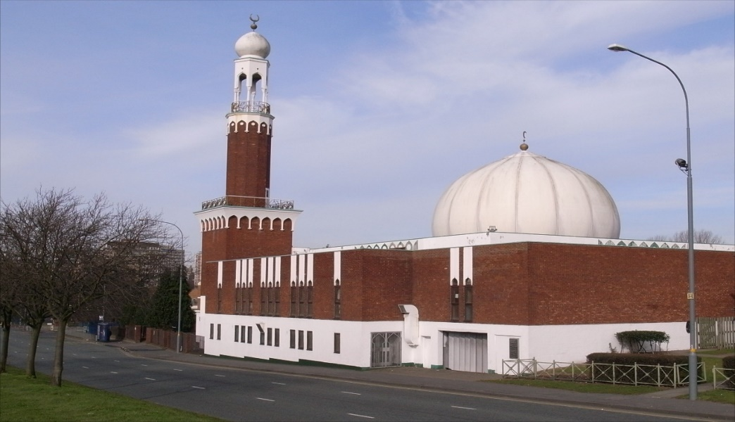
191 West Road, Westcliff – on – Sea, SS0 9DH

Do you want to know what Islam teaches?
Dates: Wednesday 19th July 2017 at 1.15pm
Wednesday 20th September 2017 at 1.15pm.
Parking: There is no car parking facilities except side roads. Car share is also encouraged where possible.

Revd. Chris. L. A. Sandy
Circuit Minister
Benfleet & Canvey Island Methodist Churches
Ph: 01268 793 313
Mb: 07496648631
5
Farewell Service Sunday 16th July 4pm at Rayleigh Come and join in the service, showing our love, support and thanks to two of our ministers. Rev Norman Hooks who will be retiring and to Rev Phil Warrey who is moving on to a new circuit.

THE STORY BEHIND THE HYMN: ETERNAL FATHER STRONG TO SAVE

The author of the words, William Whiting, was an Anglican clergyman in Winchester, which is hardly a seaside town. Yet Whiting had not only grown up by the sea, but had nearly died in it. As a young man he had been on a ship that got caught in a violent storm, and afterwards he felt certain it was only God who had saved the ship from sinking that night.

Some years later, as headmaster of the Winchester College Choristers’ School, Whiting was approached by a student in distress. The student was due to sail to the USA, and was simply terrified at the thought of 3000 miles of ocean. To try and reassure the student, Whiting decided to share his experience. And so he wrote this poem, basing the description of the power and fury of the sea on Psalm 107.

It is not known if it helped the nervous student or not, but within a year the poem had become a hymn, and sailed into the influential first edition of Hymns Ancient and Modern of 1861.

Another Anglican clergyman, John B Dykes, wrote the music for it. He was already a successful composer, with 300 hymns to his name. Dykes named this tune ‘Melita’, after an old name for Malta, where St Paul was once shipwrecked. Whiting released two more versions of the lyrics, in 1869 and in 1874.

During the rest of the 19th century the hymn became a favourite with the Royal Navy and the United States Navy. Other Services adapted it, including the Royal Marines, the Royal Air Force, the British Army, and the United States Coast Guard. Above all, it became known as the Royal Navy Hymn.

Well into the 20th century, it was the favourite hymn of President Franklin Delano Roosevelt, who had served as Secretary of the Navy during the Second World War. In 1963 Eternal Father was played by the Navy Band, as President John F. Kennedy's body was carried up the steps of the U.S. Capitol to lie in state. (Kennedy had been a PT boat commander in World War II.)

More recently, Eternal Father made a ‘guest appearance’ in the Hollywood blockbuster Titanic, and is also often chosen by ship’s chaplains for use in civilian

6
All in the month of July

It was:
100 years ago: on 31st July – 10th November 1917 – that the Battle of Passchendaele (or Third Battle of Ypres) took place in Belgium. It was one of the greatest disasters of the war for both sides. Casualty figures were enormous, but the Allies were better able to bear the heavy losses as the war continued.

Also 100 years ago: on 17th July 1917, the Royal Family changed its name from the House of Saxe Coburg Gotha, to the House of Windsor.

75 year ago: on 23rd July 1942 that the Treblinka extermination camp in Poland began operating. By Oct 1943 around 850,000 people had been gassed there.

Also 75 years ago: on 31st July 1942 that the charity Oxfam was founded in the UK (as the Oxford Committee for Famine Relief).

70 years ago: on 9th July 1947 that Buckingham Palace announced the engagement of Princess Elizabeth to Lieutenant Philip Mountbatten.

60 years ago: on 6th July 1957 that John Lennon and Paul McCartney met for the first time at a church hall in Liverpool, where 16-year-old Lennon was performing with his skiffle group, the Quarrymen. 15-year-old McCartney joined as a rhythm guitarist shortly afterwards, and the pair went on to form the Beatles.

50 years ago: on 1st July 1967 that the European Economic Community, the European Coal and Steel Community and the European Atomic Energy Community merged into a single organisation. Many people regard this event as the creation of the European Union.

40 years ago: on 1st July 1977 that British tennis player Virginia Wade won the ladies’ singles championship at Wimbledon. (She remains the last British woman to do so.)

30 years ago: on 29th July 1987 that Margaret Thatcher and French President Francois Mitterand ratified the Treaty of Canterbury – the agreement to build the Channel Tunnel. (Work began 15th December.)

20 years ago: on 1st July 1997 that the sovereignty of Hong Kong was transferred from the UK to China.

Also 20 years ago: on 20th July 1997 that the second IRA ceasefire came into effect in Northern Ireland. This led to the signing of the Good Friday Agreement in May 1998.

10 years ago: on 1st July 2007 that smoking was banned in all enclosed workplaces in England.

LADIES CLUB

Our programme for the weeks up to the Summer Holidays is as follows:

5 July Quiz
12 July Christian Aid Charity Afternoon
19 July Summer Lunch 1:00 pm Venue TBA
Elizabeth Ellis

7
SERVICES For JULY and AUGUST 2017
[S] = Sacrament of Holy Communion [P] = Parade
[B] = Infant Baptism

'02 July | '8:30 am | Rev Phil Warrey [S]
 | 10.45 am | Rev Dr David Chapman
'09 July | 10.45 am | Rev Phil Warrey [S]
 | 4.00 pm | Rev Phil Warrey [Café Church]
'16 July | 10.45 am | Local Arrangement
 | 4.00 pm | Circuit Service  Rev Peter Moorhouse
'23 July | 10.45 am | Jane Fulford
 | 4.00 pm | Rev Phil Warrey [S]
'30 July | 10.45 am | Rev Phil Warrey [P]
 | 4.00 pm | Rev Phil Warrey [Messy Church]
'06 August | 10.45 am | Rev Clifford Newman [S]
'13 August | 10.45 am | Local Arrangement
'20 August | 10.45 am | Rev Hannah Bucke [B]
'27 August | 10.45 am | Rev Christopher Reeve

CHURCH FAMILY NEWS
The last five years have flown by and now we have changes. As Rev.Phil and Caroline move on after a vibrant ministry they go with our love, prayers and good wishes. Rayleigh never lets go of its Ministers. We stay in touch and keep them in our hearts and look forward to seeing them back from time to time. They will always be part of our church family.
Congratulations to Pat Oatley who has retired from the position of Guild Secretary a post she has held for approximately 45 years, Thanks to John Lorrimore who volunteered to replace her.
WORLD MISSION
Will holders of boxes or blessing bags please hand them in before the end of July. Val Tyler

8
RAYLEIGH METHODIST CHURCH
PRAYER GROUP MEETING DATES
2017;

JULY: 12th & 26th
AUGUST: 9th & 3rd
SEPTEMBER: 6th & 20th
OCTOBER: 4th & 18th
NOVEMBER: 1st, 15th, & 29TH
DECEMBER: 13th & 27th.

ALL MEETINGS ARE IN THE WELCOME AREA,
COMMENCING AT 9.30AM,
FOR ABOUT 45 MINUTES.

FROM THE EDITORS WE NEED YOUR ARTICLES
SEPTEMBER 2017 EDITION
The deadline for this edition of the Newsletter is Sunday 9 AUGUST 2017 ( in Welcome Area) or Wednesday 12 AUGUST (through our letter box or by email).
johnward816@gmail.com

BIBLE STUDY

At this moment in time there are no meetings planned for July and August.

9
SERVICES
Sunday Services 10:45 am
Café Church 4:00 pm on the 2nd Sunday of each month
Messy Church 4:00 pm on last Sunday of each month
also occasional services at 6:30 pm.
See church noticeboard for this month’s details
Junior Church 10:45 am
Monthly Mid-Week Communion (except in August)
On the 3rd Tuesday of the month in the WESLEY ROOM at 10:30 am.

REGULAR WEEKLY MEETINGS
Monday
1:15pm Sunbeams Parent and Toddler Group
2:30 pm Women's Fellowship

Wednesday
1:45pm – 3:15pm Ladies Club
4:15 pm-5:30 pm Rainbows
5:45 pm -7:15 pm Brownie Guides
7:00 pm-8.45pm Guides

Thursday
10:00 am Care and Share
5.15 pm- 6.15pm Beavers
6:30 pm - 7:45 pm Cubs
8:00 pm – 9:30pm Scouts
8:00 pm Wesley Guild (Sept to May only)

Friday
4:30 pm-5:45 pm Rainbows
5:30 pm-7:00 pm Brownie Guides
7:15 pm -9:00 pm Guides
7:15 pm -9:00 pm Guides Senior Section (fortnightly)
Preschool
9:15-11:45 am & 12:30-3:00 pm (Mon. mornings only)

Editors John and Sue Ward 9 Sheridan Close Rayleigh SS6 8YR Telephone 01268 742847 (johnward816@gmail.com)

