RAYLEIGH METHODIST CHURCH

Eastwood Road
Rayleigh
Minister
Rev. Stephen Watts 01268 770333

THE NEWSLETTER
September 2017

1
A Message from the Stewards

Happy New Year!

The new Methodist year is bringing us lots of changes.
From September 1st our new minister will be Rev. Stephen Watts. He and his wife, Valerie will be arriving in Rayleigh on Wednesday 30th August. We wish them a happy and blessed time here. It is planned that Rev. Stephen will be minister of Rayleigh and Hockley, so his time will not be spread as thinly as it was with previous ministers.

It is also hoped that a youth and family worker will be in place soon to support the work in Hockley and Rayleigh with young people and families.
You may have heard already that Rev. Stephen has had to have emergency surgery on his spine at Stoke Mandeville Hospital. He is currently in a wheelchair and adaptations are being made to the Manse. He is hoping to make a full recovery. Please pray for Rev. Stephen and Valerie at this difficult time.

May I take this opportunity to thank everyone for their help during Rev. Phil and Caroline's last services in Rayleigh. It was a great occasion. Thanks to many people who helped by bringing salads, quiches, cakes and puddings, and to a few who worked incredibly hard in the kitchen.
The stewards and Rev Stephen are already planning lots of activities for the next few months. Our pattern of services remains the same as it was, and we are looking forward to Harvest Festival and Messy Church at the end of this month.

Breakfast Club
The Breakfast Club Rayleigh Methodist Church works in tandem with the Family Hub (Children's Centre). They provide activities for young children and advice to parents: we provide hot drinks, toast and cooked breakfasts. This is a brilliant way of reaching young families. Two of the children baptised here recently have come to us through Breakfast Club.
Volunteers are still needed on Monday mornings to help set up the room, take orders, chat to the parents, or cook breakfast. Please contact Pat Norman if you would like to help: 07886476890

2
CHURCH FAMILY NEWS
A warm welcome is given to our new Minister Rev. Stephen Watts and
his wife Valerie as they join our church family. We hope they will
be happy in Rayleigh.
Renee Crompton has become a great grandmother with the birth of a son
to David and Jessica on 2nd August, his name to be notified later.
Congratulations and best wishes to all the family.
The death has occurred of Madge Twist, a long-standing member and
friend who in recent years was in residential care. Loving sympathy
goes to her family.
Please remember to send in your news.
If you don't know who I am ask a steward.
Val Tyler

WOMEN'S FELLOWSHIP
Women's Fellowship will be hosting a Coffee Morning on Saturday, 21st
October - 10 a.m. to 12 noon.
Before the summer break we enjoyed lunch prepared by our hardworking
catering team, an opportunity to say goodbye to Phil and Caroline and
to thank them for all their support and care. This was followed by
entertainment by the Ladybirds singing group.
Here is the programme for September:
4th September Welcome Back Social
11th September Speaker Linda Hunt - Rayleigh Library
18th September Speaker Rev. Clifford Newman
25th September A.G.M.
We would be pleased to welcome new members or anyone who wishes to
give us a try. Meetings start at 2.30 p.m.
Val Tyler (Elaine is on holiday)

3
Church Treasurer

As you may be aware when I took over the role of Treasurer in April I agreed to cover the role for 6 months to allow the church time to find a suitable individual to take responsibility for our finances on a more permanent basis. This would take the church past the end of the financial year and the significant amount of work involved in preparing the necessary reports to meet the requirements of the Charity Commission and the Methodist Church.

As I write this note we are already more than 4 months into this period, which expires in October, and I am not aware of anyone having expressed an interest in taking on the role within the timescale.

The Treasurer must be a member of the Methodist Church.

I would ask that anyone who thinks that their calling may include considering the very important role of Treasurer makes contact with me when I would be pleased to talk them through what is involved.

John Mayfield
Acting Treasurer

The Big Project

I hope that you are all aware of the Big Project and the plans that were agreed by Church Council earlier this year to refurbish certain areas of the church to better meet the needs of the people who use our premises.

A lot of work has been going on, some of it in the background, and I thought it was now appropriate to bring you up to date what has been achieved and what remains to be done.

Welcome Area – the 12 misted windows have been replaced, a new flat roof laid, the rendering repaired, a new carpet laid and the area decorated both inside and out. New external signage installed and illuminated. Complete.

Entrance to Crush Hall - ramp installed with handrails and new doors to the Crush Hall to facilitate access. We are still working on the best way of marking the edge of the step where the paint is coming off. Bascially complete.

4

External Store – for those with a long memory this used to be the original (external) gents toilets for the church, although for some time now it has been used for storage. The original sanitary ware has been removed together with the internal walls. The walls have been prepared and painted and metal racking has been installed. The two old Crittal windows have been replaced with new units to match the rest of our buildings. Complete.

School Rooms Toilet Area and Lobby – this is the major and most expensive part of the scheme and will be ongoing during August. All the sanitary ware and fittings, the internal walls, ceiling tiles and floor tiles have been removed. The existing toilet area has been converted to accommodate two child cubicles and one adult cubicle each with hand basins. The plastering has been completed. Vinyl flooring will be laid in the cubicles and the lobby. All areas involved to be painted. This work is ongoing and is on schedule to be completed by the 1st September.
Aldersgate Room – A sink is being installed.
Wesley Room – the fluorescent lights have been replaced with LED fittings similar to those in the Nash Hall. New cupboards will be built to replace at least some of those currently in the room. The room will be redecorated and a new carpet laid. It is also hoped to install a hearing loop. This work has started but the majority of it will probably be undertaken in October.

The budget agreed by Church Council for the overall project was some £51,000 of which we have so far paid out some £30,400 as I write this article on the 16th August.

The next question you should be asking yourself is how we are going to pay for all this work. The answer is that we have managed to raise funds from the following sources and we are very grateful for all the support we have received.

Sale of land at Connaught Road owned by Rayleigh Methodist Church - £28,150
Grant from the Big Lottery - £9,000
Grant from the Osborne Trust - £5,000
Grant from Methodist Insurance - £5,000
Grant from Southend and Leigh Circuit of Methodist Church - £3,000
Grant from Beds, Essex and Herts District of Methodist Church - £1,100
Grant from Allchurches Trust - £900

If anyone has any questions or concerns then please contact me.
John Mayfield (Acting Treasurer)

5

THE GOSPEL
You are writing a gospel,
A chapter each day,
By the deeds that you do,
By the things that you say.
People read what you write,
Whether faithless or true,
And say, “what is this gospel
According to you?”

People read and admire
The gospel of christ,
With its love so unfailing and true,
But what do they say and what do they think
Of the gospel according to you?

It’s a wonderful story,
Christ’s gospel of love,
And it shows that his love is divine:
I hope that it’s content will be there again
In the story of your life and mine.
You are writing each day a letter to others,
Take care that the writing is true –
It’s the only gospel that some others will read,
That gospel according to you.

HARVEST FESTIVAL
This year we are celebrating Harvest on Sept. 24th. As usual we will be decorating the church. We obviously need your help and are having retiring collections after Morning Service on Sundays Sept. 10th and 17th. If you would prefer to give your donation to me please feel free to do so. Margaret Babbage.
THANKS
Derek and myself would like to thank everybody for the lovely flowers delivered to us while Derek was in hospital. It was lovely of everybody to think of us. Whilst Derek's recuperation is likely to be a long job we are hoping we have now turned the corner.
Pat and Derek Shephard
6

SERVICES For SEPTEMBER 2017
[S] = Sacrament of Holy Communion [P] = Parade
[B] = Infant Baptism HF = Harvest Festival

'03 September | '8:30 am | Rev Stephen Watts [S]
 | 10.45 am | Rev Stephen Watts
'10 September | 10.45 am | Rev Moon [S]
 | 4.00 pm | Rev Stephen Watts [Café Church]
'17 September | 10.45 am | Sue Hockett  Rev Clifford Newman [B]
'24 September | 10.45 am | Rev Stephen Watts [HF]
 | 4.00 pm | Rev Stephen Watts [Messy Church]

WELCOME SERVICE

The welcome service for Rev Stephen Watts, Rev Nana Banyin Thormwood, Pastor Stephen Mayo and Mr Matthew Cook a One Programme Participant along with their families as they move into our circuit, is being held at Rayleigh Methodist Church on Tuesday 5 September at 7:30 pm.
Our District Chair, Rev Dr. David Chapman will be preaching

You are invited to a
COFFEE MORNING
at Rayleigh Methodist Church
for
DOLPHIN COURT
(Cheryl Harris)
on
Saturday 16 September 2017
10.00 to 12.00 noon
It will include the following stalls, cakes cards, books, bric-a-brac,
and much more

7
Membership figures do not tell the whole story

The Methodist Church in Britain has revealed a 3.5% year-on-year decline in membership over the past decade, with membership now at 188,000, but continues to reach over half-a-million people each week.

While local church membership has decreased, the triennial Statistics for Mission report presented to the Methodist Conference this week, also showed that general involvement in Methodist churches - through cafés, youth clubs and alternative forms of church – is continuing to be an important aspect of the Church, reaching an estimated half a million people each week.

Mr Doug Swanney, the Connexional Secretary, presenting the report said: “Like many others, I know the deep joy and profound impact that finding a home in the Methodist Church has had in my faith journey, and I know that I desperately want others to have that same experience.
“We continue to rejoice in the good news stories and shoots of growth in certain areas of the Methodist Church, but we cannot ignore the importance of these numbers.

“While it does make for a challenging read, it’s important to remember that membership figures alone don’t tell the whole story. Across the country, thousands of Methodist communities are impacting the lives of hundreds of thousands of people every week in a wide variety of ways.”

The Revd Loraine N Mellor, President of the Methodist Conference highlighted the issue in her Presidential Address on Saturday: “I know I am part, at present, of a declining Church, but I am not part of a declining gospel. The gospel of Jesus Christ is here to stay, but has the time not come of us to be radical? To take some risks in order that we can grow… Because, you see… I don't believe that God is done with us just yet.”

The Revd Canon Gareth J Powell, Secretary of the Conference, said: “At the heart of this report is a challenge – not with the statistics, but with the very nature of our being. We must take seriously our responsibility for being an evangelistic community of love – a profound giving of attention to another person - which leads people to Christ.”

8
LADIES CLUB

Our programme for the Autumn Term is as follows:

6 September - Harvest Lunch - 1pm
13 September AGM
20 September - Clive Lewis - Uganda
27 September - Macmillan Coffee afternoon - 2pm

4 October - Vivien Finch
11 October - Laura Bayley - Fire Safety
18 October - Time to talk
25 October - half term

1 November - Nick Kemsley - Action Fraud
8 November - Maz Morgan
15 November - Let's go to the movies
22 November - Karisma ( Entertainment please invite your friends)
29 November - Christmas crafts - Eileen and Sandra

6 December - Carol service -2.30pm
13 December - Christmas lunch – tba

Elizabeth Ellis

WESLEY GUILD

Our Programme for September is as follows:

14 September Coffee Evening
21 September Presidents Address
28 September Tracy Kemsley- Life as a woman police officer.

Do come and join us at 8pm on Thursday for a nice cup of tea or coffee. (well relatively anyway)

John Lorrimore (Secretary)

9
Encourage one another
Is there someone who is lonely?
Then reach out with a touch,
A little love, a little time,
It really isn’t much.

And is there somebody hurting?
Then why not draw alongside,
Be prepared to share the silence,
Of the pain and grief they hide.

Maybe someone is discouraged,
You should give a word of cheer,
A letter, perhaps a phone call,
Just to let them know you’re near.

And somebody else is struggling,
Let them know you really care,
Think of practical ways to help
And when they need you – be there!

Then there is always the stranger,
Who feels lost and out of place,
Go and greet them in the lord’s name,
Let them see a smiling face.

Another is always serving,
But they may grow tired too,
And you can help to refresh them,
With two little words – thank you!

So, encourage one another,
And follow the master’s way,
Let his holy spirit use you,
To meet other’s needs each day.

Be ready then with a shoulder,
A warm handshake or a hug,
Remember, you are Christ’s body,
So reach out with his arms of love!
10
WHAT IS WORSHIP ACADEMY?
Have you heard of Worship Academy, and been just a bit curious as to what it might be?
It is on-going training for all leaders of worship, and was Phil’s brain child four years ago. It has been very successful and well supported in this Circuit. Other areas are interested in setting up something similar, using our model as a template.
The meetings take place monthly at Benfleet, and are open to anyone who leads worship; Worship Leaders, Local Preachers, Ministers, and those interested in a particular subject.
The serious stuff is preceded by a meal, where we can chat and mingle with colleagues from around the Circuit.
We have a short time of worship, before the Academy bit begins. The speakers are very varied, but we often use “in house” talent.
We have had an extraordinary variety of speakers, speaking on a wide variety of subjects. Anything from The Julian Movement, (silent worship and contemplation), to discussions on assisted dying/end of life care, how to fill the Sermon slot, (Worship Leaders are not allowed to preach), and Praying with Hymns. We have had visits from the Christian Bookshop, discussed resources, including the imaginative use of media. Had in-house discussions, and visited Wesley’s Chapel and Southend Synagogue. A trip to the Mosque in West St is planned.
The Worship Academy meetings have been instructive, informative and (mostly!) interesting. Although some, I have to admit have been challenging to me personally, and on the rare occasion, a bit over my head.
Of course the social aspect of these meetings is as beneficial as the tuition. We have learnt a lot from each other, been encouraged, and shared ideas as part of our ongoing training.
We thank Phil for the blessing of Worship Academy, and look forward to continuing to expand our thoughts, and opening our minds to new ideas. Hopefully this will translate into the services we are invited to take part in, or arrange at this Church.
So next time you hear us talking about Worship Academy, you will know what it is, and that it’s enjoyable but hard work! JANET WARNER.
11

RAYLEIGH METHODIST CHURCH
PRAYER GROUP MEETING DATES
2017

SEPTEMBER: 6th & 20th
OCTOBER: 4th & 18th
NOVEMBER: 1st, 15th, & 29TH
DECEMBER: 13th & 27th.

ALL MEETINGS ARE IN THE WELCOME AREA,
COMMENCING AT 9.30AM,
FOR ABOUT 45 MINUTES.

FROM THE EDITORS WE NEED YOUR ARTICLES
OCTOBER 2017 EDITION
The deadline for this edition of the Newsletter is Sunday 10 September 2017 ( in Welcome Area) or Wednesday 13 September (through our letter box or by email).
johnward816@gmail.com

BIBLE STUDY

10am Friday 29th September at Clifford and Linda's

2 Samuel Chapters 3 - 5

12
CHRISTIANS TAKE NOTE
Queensland education department joins the growing list of persecutors of faith. Andrew Bolt (Australian Columnist and Broadcaster

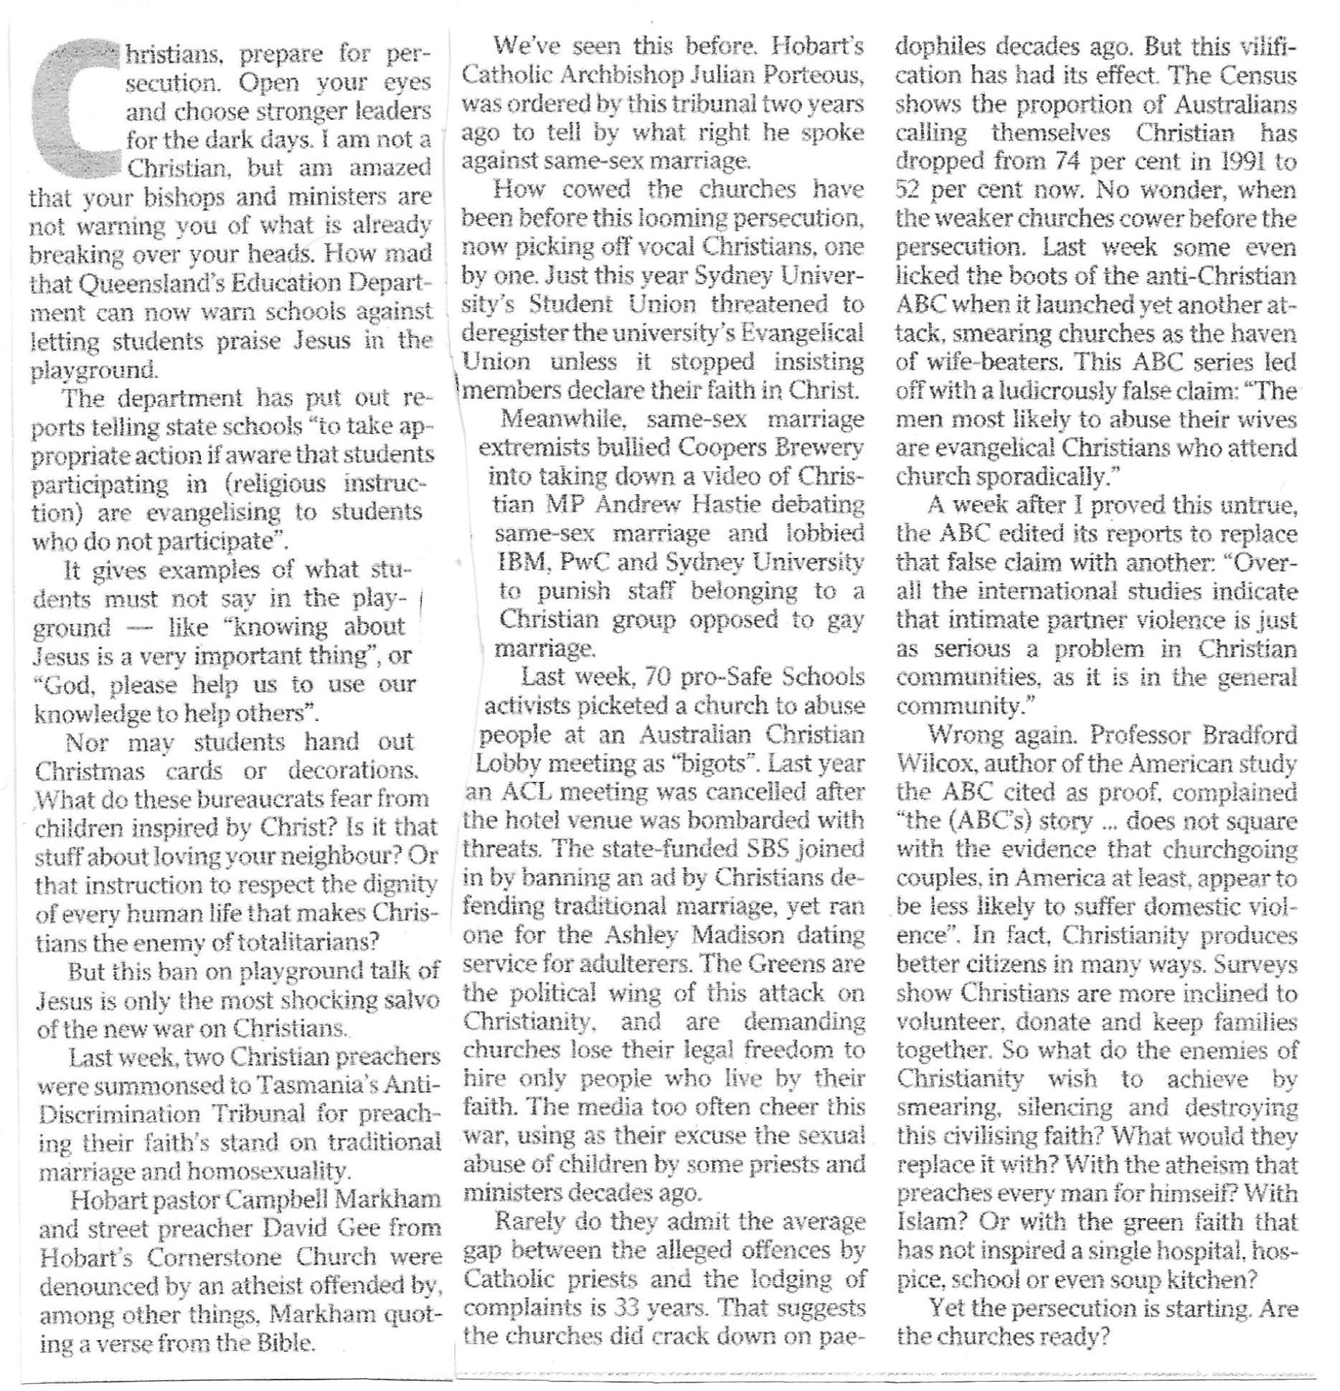

SERVICES
Sunday Services 10:45 am (inc. Junior Church & Creche)
Café Church 4:00 pm on the 2nd Sunday of each month
Messy Church 4:00 pm on last Sunday of each month
also occasional services at 6:30 pm.
See church noticeboard for this month’s details

Monthly Mid-Week Communion (except in August)
On the 3rd Tuesday of the month in the WESLEY ROOM at 10:30 am.

REGULAR WEEKLY MEETINGS
Monday
1:15pm Sunbeams Parent and Toddler Group
2:30 pm Women's Fellowship

Wednesday
1:45pm – 3:15pm Ladies Club
4:15 pm-5:30 pm Rainbows
5:45 pm -7:15 pm Brownie Guides
7:00 pm-8.45pm Guides

Thursday
10:00 am Care and Share
5.15 pm- 6.15pm Beavers
6:30 pm - 7:45 pm Cubs
8:00 pm – 9:30pm Scouts
8:00 pm Wesley Guild (Sept to May only)

Friday
4:30 pm-5:45 pm Rainbows
5:30 pm-7:00 pm Brownie Guides
7:15 pm -9:00 pm Guides
7:15 pm -9:00 pm Guides Senior Section (fortnightly)
Preschool
9:15-11:45 am & 12:30-3:00 pm (Mon. is mornings only)

Editors John and Sue Ward 9 Sheridan Close Rayleigh SS6 8YR Telephone 01268 742847 (johnward816@gmail.com)

