RAYLEIGH METHODIST CHURCH

Eastwood Road
Rayleigh
Minister
Rev. Stephen Watts 01268 770333

THE NEWSLETTER
OCTOBER 2017

1
FROM THE MINISTER
While I was lying in my hospital bed recently, recovering from spinal surgery, I decided that I would compose my ﬁrst written message for you. I spent many days on it altering it from time to time as my thoughts, feelings and general well-being were examined thoroughly. I thought it was a good letter, with many points I wanted to put forward.

Where is it now? well I guess its up there in the ether because I decided that things have moved on from there. Just after a serious operation you think many things, you have a lot of time to do so. Some of those things can be quite dark when you are in a difﬁcult place.

But I have moved on from that place, yes I have received quite a jolt to my conﬁdence but as each day progresses, there is a promise of better things.

I am sure that for many of you the moving on of the previous minister was difﬁcult. You build up relationships, ways of doing things, and you become comfortable. He will be a difﬁcult act to follow, but that is what happens in Methodism today, we move on.

Both Valerie and I come to serve you here in Rayleigh. We have moved further away from family to do so. When I offered myself I wanted to be somewhere that needed me and I hope that the stationing process is proved right. There will be tough times ahead for us all but I pray that we will be accepted into your family so that we might share both good and not so good together.

I hope that there will be plenty of opportunity to share my journey with you, and I am sure you will want to tell me things about yourselves. We both have a listening ear and I hope caring hearts. Let us travel the road together until we move on. Hopefully as time goes by my slow process of healing will take place and I won’t always be in a wheelchair!
Every Blessing
Steve and Valerie Watts

2
CHURCH FAMILY NEWS
With sadness the death is announced of Muriel Dallimore, a long-standing member who had been connected with this church since childhood and still lived in the family home. Muriel was very involved
in church life and will be much missed. Loving sympathy goes to her friends and family, especially Betty Day who was Muriel's cousin.
Our thoughts are with Ron Myatt as he recovers from his hip operation.
Greetings and best wishes to Louisa McNamara who celebrated her 90th birthday on September 15th.
Aaron Vale has started at Fitzwimarc school in plaster, having broken his arm during the summer holidays. We hope this will soon be mended.
No other news of younger friends has been received, such as exam results.

Val Tyler

WOMEN'S FELLOWSHIP

2 October Speaker Rev Stephen Watts

9 October Speaker Linda King
Methodist Women in Britain Project
16 October Speaker Isobel Brown
A Musical Afternoon

23 October Members Afternoon

30 October Speaker Helen Rubinstein
Watercolour Painting

We will be hosting the coffee Morning
on Saturday 21st of October 10.00 to 12,00 noon

Elaine Blades

3
SERVICES For OCTOBER 2017
[S] = Sacrament of Holy Communion [P] = Parade
[B] = Infant Baptism HF = Harvest Festival

'01 October | '10.45 am | Rev Stephen Watts [S]
'08 October | 10.45 am | Pam Smith
 | 4.00 pm | Rev Stephen Watts [Café Church]
'15 October | 10.45 am | Rev Stephen Watts
'22 October | 10.45 am | Rev Chris Sandy
 | 6.30 pm | Rev Stephen Watts [S]
'29 October | 10.45 am | LA
 | 4.00 pm | LA [Messy Church]

You are invited to a
COFFEE MORNING
at Rayleigh Methodist Church
for
CHRISTIAN HOPE (see pages..4 and 12)
(Elaine Bladess)
on
Saturday 21 October 2017
10.00 to 12.00 noon
It will include the following stalls, cakes cards, books, bric-a-brac,
and much more
THANKS

My grateful thanks to those who helped in anyway with the refreshments etc following Muriel Dallimore's funeral.
Best wishes, Betty Day

4
CHRISTIAN HOPE INTERNATIONAL
WHAT DO WE DO AND WHY DO WE DO IT??
Christian Hope International seeks to bring the true hope only found in Jesus Christ along with practical support to those in need in Africa and Eastern Europe. Jesus’ life and teaching are the motivation for our work.
Working in partnership with the Christian Community in the ‘Developing World’ we seek to glorify God by providing practical aid, resourcing small community projects and enabling children to receive a good education through child sponsorship.

CHURCH FIRST AID BOX

This is located in the kitchen.

If you have to use a plaster or any other of the contents please make sure the details are entered with a comment regarding the incident, however trivial, in the accident book. This will enable replenishment of the box, ensuring the contents are up to date.
Nothing worse than spending time searching for a bandage if it isn’t in the box.

RELIGIOUS STUDIES CAN LEAD TO A ‘VERY BRIGHT’ FUTURE

RS is still the fastest-growing A-level subject among the arts, humanities and social sciences in the UK. It is the second fastest after Further Maths.

Now the National Association of Teachers of RE (NATRE) and the Religious Education Council of England and Wales (REC) have emphasised the importance of the subject in the UK. They stress that universities and employers are increasingly recognising the value of religious literacy. They also say that career prospects are ‘very bright’ for those studying RS or theology at degree level.

5
TIME FOR OPERATION CHRISTMAS CHILD SHOEBOXES

It is time to start collecting children’s toys and finding a shoebox to send to a child living in poverty in any one of up to 100 countries worldwide.

This year Operation Christmas Child worldwide is hoping to send up to 12 million shoe boxes from countries such as the UK, the USA, Canada, Australia and Germany, to needy children who will otherwise have no presents at all this Christmas. Details at: https://www.samaritans-purse.org.uk/what-we-do/operation-christmas-child/

Rayleigh OCC are having a quiz on Saturday 7 October
at Holy Trinity Church Hall
7:15 pm for a 7:30 pm Start
Teams of up to 8 people
Please bring your own drinks and nibbles
Donations of money and Shoebox items on the night – money will go towards transport costs.
For team booking email or telephone

OCC warehouse dates, (volunteer forms will be available soon).
Fridays 10 17 24 November and 1 December
Saturdays 11 18 25 November
Mondays 13 20 27 November
Tuesdays 14 21 28 November
SATURDAY 2 DECEMBER LORRY LOADING

Further details from Dilys Hand

6
ALL IN THE MONTH OF OCTOBER

500 years ago: on 31st Oct 1517 that German priest and theologian Martin Luther is said to have posted his Ninety-Five Theses on the door of All Saints’ Church in Wittenberg on this date, triggering the start of the Protestant Reformation.

175 years ago: on 20th Oct 1842 that Grace Darling, British heroine, died. She had famously rescued survivors of a shipwreck off Northumberland in 1838. She and her father used a rowing boat as the sea was too rough for the lifeboat. (She dies of tuberculosis, aged 26.)

125 years ago: on 6th Oct 1892 that Alfred, Lord Tennyson, died. This popular poet was Poet Laureate (1850-92) and is best known for ‘The Charge of the Light Brigade’.

100 years ago: on 12th Oct 1917 that WW1’s Third Battle of Ypres took place, the First Battle of Passchendaele, in Belgium. It was a German defensive victory, but a costly battle on both sides. Anzac forces suffered heavy losses.

65 years ago: on 6th Oct 1952 that the world premiere of Agatha Christie’s play ‘The Mousetrap’ took place in Nottingham. It opened in London on 25th November 1952 and is still running, making it the world’s longest-running play. It has been performed more than 25,000 times.

60 years ago: on 10th Oct 1957 that the Windscale nuclear reactor in Cumbria caught fire. The Windscale (now Sellafield) fire spread radioactive contamination over the UK and Europe. It was the worst nuclear accident in British history and is thought to have caused hundreds of cancers.

30 years ago: on 15th Oct 1987 that the Great Storm hit southern England. Hurricane-force winds killed 18 people and caused £2billion worth of damage. 15 million trees were lost. Weather forecasters were criticised for failing to predict the severity of the storm.

7
TIME TO SMILE

Music
The symphony musicians had little confidence in the person brought in to be their new conductor. Their fears were realised at the very first rehearsal. The cymbalist, realising that the conductor did not know what he was doing, angrily clashed his instruments together during a delicate, soft passage. The music stopped. The conductor, highly agitated, looked angrily around the orchestra, demanding, "Who did that? Who did that?"
Broad
Middle age is when broadness of the mind and narrowness of the waist change places.
Dreams
Realise your dream! Unless it's the one where you're at work in your underwear during a fire drill.
Accident
As my five-year-old son and I were heading to McDonald's one day, we passed a car accident. Usually when we see something terrible like that, we say a prayer for whoever might be hurt, so I pointed and said to my son, "We should pray." From the back seat I heard his earnest voice: "Dear God, please don't let those cars block the entrance to McDonald's."
Stories
As part of his talk at a banquet, our minister told some jokes and a few funny stories. Since he planned to use the same anecdotes at a meeting the next day, he asked reporters covering the event not to include them in their articles. Reading the paper the following morning, he noticed that one well-meaning cub reporter had ended his story on the banquet with the observation "The minister told a number of stories that cannot be published."
Sticks
Long ago when men cursed and beat the ground with sticks, it was called witchcraft. Today, it's called golf.

8
LADIES CLUB

Our programme for the Autumn Term is as follows:

27 September - Macmillan Coffee afternoon - 2pm

4 October - Vivien Finch
11 October - Laura Bayley - Fire Safety
18 October - Time to talk
25 October - half term

1 November - Nick Kemsley - Action Fraud
8 November - Maz Morgan
15 November - Let's go to the movies
22 November - Karisma ( Entertainment please invite your friends)
29 November - Christmas crafts - Eileen and Sandra

6 December - Carol service -2.30pm
13 December - Christmas lunch – tba

Elizabeth Ellis

WESLEY GUILD

5 October No meeting
12 October Rev. Steven Watts
19 October Roger Plumstead- Four seasons Slide show
26 October 7.30 pm Food and Fun.. ticket only - from Guild members.

Come and join us at 8pm on Thursday evenings for a friendly get together.

John Lorrimore. (secretary)

9
GOLF

There was a clergyman who was an avid golfer. One Sunday was a picture-perfect day for golf, and the minister could not resist the temptation. He rang his assistant and told him he was too ill to attend church. Then he packed up the car, and drove three hours to a golf course where no one would recognise him. Happily he began to play the course. But an angel up above was watching the minister and was quite perturbed. He went to God and said, “Look at the minister. He should be punished for what he's doing.”

God nodded in agreement. The minister teed up on the first hole. He swung, and the ball sailed effortlessly through the air and landed right in the cup three hundred and fifty yards away. A perfect hole-in-one. The minister was amazed and overjoyed. The angel was a little shocked. He turned to God and said, “Begging your pardon, but I thought you were going to punish him.” And God smiled, “Think about it who can he tell?”

The Bible in 50 words

God made Adam bit Noah arked Abraham split

Joseph ruled Jacob fooled Bush talked Moses balked

Pharaoh plagued People walked Sea divided Tablets guided

Promise landed Saul freaked David peaked Prophets warned

Jesus born God walked Love talked Anger crucified

Hope died Love rose Spirit flamed Word spread

God remained.
anon

10
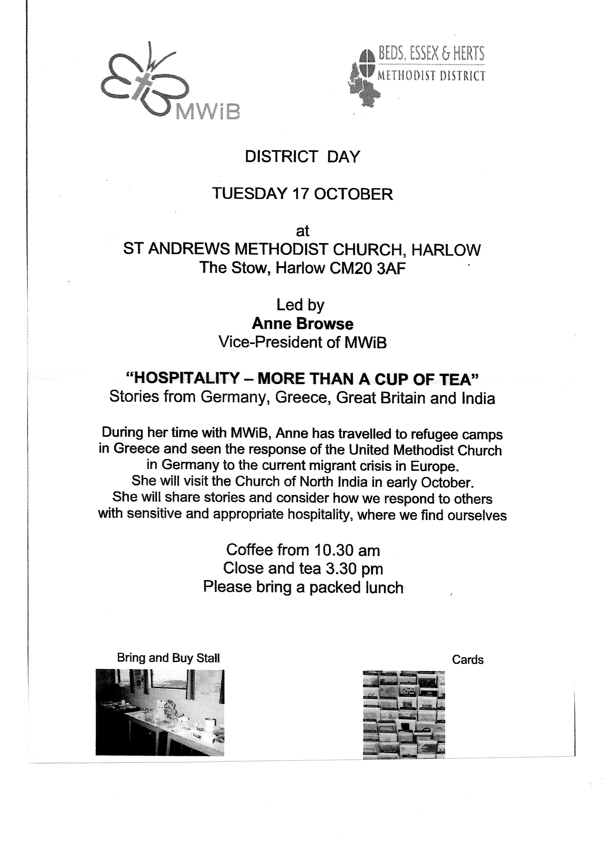
For Further details please see Sandra Hyslop or Val Tyler

11

RAYLEIGH METHODIST CHURCH
PRAYER GROUP MEETING DATES
2017;

OCTOBER: 4th and 18th
NOVEMBER: 1st, 15th, and 29TH
DECEMBER: 13th and 27th.

ALL MEETINGS ARE IN THE WELCOME AREA,
COMMENCING AT 9.30AM,
FOR ABOUT 45 MINUTES.

FROM THE EDITORS WE NEED YOUR ARTICLES
NOVEMBER 2017 EDITION
The deadline for this edition of the Newsletter is Sunday 16 October 2017 ( in Welcome Area) or Wednesday 19 October (through our letter box or by email).
johnward816@gmail.com
BIBLE STUDY

10am Friday 27th October at Clifford and Linda's.

Readings are 1 Samuel Chapters 6, 7, 11, 12

12

SERVICES
Sunday Services 10:45 am
Café Church 4:00 pm on the 2nd Sunday of each month
Messy Church 4:00 pm on last Sunday of each month
also occasional services at 6:30 pm.
See church noticeboard for this month’s details
Junior Church 10:45 am
Monthly Mid-Week Communion (except in August)
On the 3rd Tuesday of the month in the WESLEY ROOM at 10:30 am.

REGULAR WEEKLY MEETINGS
Monday
1:15pm Sunbeams Parent and Toddler Group
2:30 pm Women's Fellowship

Wednesday
1:45pm – 3:15pm Ladies Club
4:15 pm-5:30 pm Rainbows
5:45 pm -7:15 pm Brownie Guides
7:00 pm-8.45pm Guides

Thursday
10:00 am Care and Share
5.15 pm- 6.15pm Beavers
6:30 pm - 7:45 pm Cubs
8:00 pm – 9:30pm Scouts
8:00 pm Wesley Guild (Sept to May only)

Friday
4:30 pm-5:45 pm Rainbows
5:30 pm-7:00 pm Brownie Guides
7:15 pm -9:00 pm Guides
7:15 pm -9:00 pm Guides Senior Section (fortnightly)
Preschool
Mon 9:15 am to 11:45 am
Tues Weds Thurs Friday 9:15-11:45 am & 12:30-3:00 pm

Editors John and Sue Ward 9 Sheridan Close Rayleigh SS6 8YR Telephone 01268 742847 (johnward816@gmail.com)

