Eastwood Road
Rayleigh
Minister
Rev. Stephen Watts 01268 770333
Coordinating Steward
Mrs Pat Norman 01268 781896

RAYLEIGH METHODIST CHURCH

Price 30p

THE NEWSLETTER
SEPTEMBER 2018

Dear All,

As I write this article for the newsletter, I am on holiday and I want to share with you my experience. Close you eyes and enjoy.
The sun is blazing down in all its glory as I dangle my toes in the infinity pool which is just the right temperature. Ha ah, the waiter approaches with my pina colada which is part of my All inclusive drinks package. (I should have been a paper back writer).The sun is beginning to set as I gaze out onto the lagoon and see a pod of dolphins cavorting in the calm waters, with each orchestrated leap terminating in a shower of crystal bubbles which dance on the water for a time before becoming once more part of the vast ocean, most of which is undiscovered and yet polluted beyond belief by selfishness of man. The strains of Eric Clapton are in the background reminding me that its late in the evening. (Its at this point where we hear the scratch of the needle across the record and are brought back to reality.
I’m actually sat in my caravan not a million miles from Sutton on Sea, dreaming. Don’t get me wrong, I will get just as much pleasure watching the donkeys on the beach at Cleethorpes, having a fresh donut and a mug of tea sat in my van. “Don’t forget to bring the mugs back luv” There are other seaside resorts available.

Fact is we are nearly a year into my appointment which has seen change for all of us. Most of that has been the need for you to get used to me and me to you. Well, we have only just started, its a long and winding road and my old friend Elenor Rigby said that it. Was not going to be easy.

In October we are having a day when hopefully as many of us as can will be meeting to discuss the way forward over some lunch, sadly no bottle of wine. We have a lot to talk about and hopefully we can come up with some answers. Let me give you some pointers.

Church mean different things to different people. You cannot expect everyone to pile into a standard Sunday morning service and come out on a high. If you go to messy church, you might not get anything from it, you might put something into it such as, support. Next time you are in church, look around you, what can you offer, what can you do. Everybody should be doing something even in a small way.

Enjoy the rest of the summer

Steve

WOMEN'S FELLOWSHIP

Programme for September 2018
3 September Welcome Back Social
10 September Speaker Teresa Rutterford
17 September Speaker Brian Carline
"Our Steel”
24 September A.G.M.
Elaine Blades

CARETAKER
Our new caretaker Tom Crockett starts on the 1 September.
However he expects to move into the cottage with Laura in August and you will probably see them about.
Please look out for them and give them a warm Rayleigh welcome.

Where are we going?
Our strategy for the next five years for our church
As preparation for our Church Away Day, where we are all (that means you!) looking to plan out the future for our church, the following may help ‘set the scene’ for us.
It might look a bit lengthy, but read a few paragraphs at a time and aim to reach the end. Hopefully it will set the atmosphere and context for our discussions.
Ephesians 3:20 – ‘Now to him, who by the power at work within us, is able to accomplish abundantly far more than all we can ask or imagine…’
These words speak of the amazing power of God working in and through us, and of the extraordinary way in which this divine power can do more than we can ever imagine or ask.
In June, a lecture was given in London by Prof. Marcelo Gleiser. He is Professor of Physics and Astronomy at Dartmouth College, USA and teaches a course called ‘Poetry and Cosmology’.
He spoke about the amazing vastness of this galaxy in which our solar system exists – the Milky Way has anything between 200 billion and 400 billion stars, and billions of planets too. But the Milky Way is just one, not especially big galaxy – for example the Andromeda Galaxy has perhaps one trillion stars. And although astronomers don’t really know, there are probably an incredible two trillion galaxies in the universe!
Your head will probably be spinning by now! Those are seriously big numbers, far too big to imagine, and what they add up to is a universe with maybe 1,000,000,000,000,000,000,000,000 stars in it. By now, as we read this, we are probably feeling like a completely insignificant speck – so small that we might as well not exist at all. But then his talk took a new direction. He started explaining, in strictly scientific terms, about the amazing specialness of the Earth,

and about the strong possibility that conscious life is unique to this planet on which we live. What a heart-warming feeling - that maybe we aren’t so insignificant after all.
When St. Paul wrote to the Ephesians he didn’t know about the extraordinary number of galaxies and stars and planets in the universe. But he summed up similar thoughts: ‘Now to him who by the power at work within us is able to accomplish abundantly far more than all we can ask or imagine…’
That expression ‘abundantly far more…’ is actually what’s known as one of Paul’s super-superlatives – trying to capture in words something almost too vast, too wonderful to put in writing. Translators have struggled to do it justice as an idea, coming up wi things like ‘immeasurably more’ or ‘infinitely more’. Nowadays we might be inclined to say, ‘mind-blowingly more’. (Well some of us might!)
We get the idea that there are no limits to what God can do. And this means we have to recognise our place within God’s sovereign purposes rather than trying to fit God into our own plans.
And this actually fits beautifully with the emphasis on prayer that Paul’s letter to the Ephesians has running right through it. Prayer is not about bending God to our objectives, but rather is about joining in the powerful purposes of God, revealed to us above all else in Jesus Christ.
Right near the start of the letter, in verses 19 and 20 of chapter one, we discover that God’s amazing and limitless power and ability to accomplish things is seen most definitively in the resurrection and ascension of Jesus Christ (verse 20). But we also discover another amazing thing. This power from God is available to those who believe (verse 19). And that includes us!
This is one of those key bridges between Jesus and his people; a reminder that the Christian faith is not a set of abstract ideas but is lived out through prayer and action.

This power from God is not like a magic trick that allows us to distort reality in our favour. Rather, it’s a power that sweeps aside everything that would otherwise distort God’s creation. Ultimately, it’s a power that overcomes sin and death, and reveals the promise of eternal life.
The call on Christians is to live their lives in the light of this extraordinary power, even if the daily pains and challenges seem to crowd in. This can be really tough, especially if serious setbacks occur or someone whom we love is suffering. But the message of these verses is that, by this power, God is able to do far more than we can possibly even think of.
This could be scary – we feel (rightly) as though we’re out of control of our own futures, an insignificant speck in a vast universe. But it shouldn’t be scary – it should rather drive us to prayer and praise, giving glory to God, as precious and unique in his sight.
Did you notice that Paul writes about ‘us’ and what ‘we can ask or imagine’? This isn’t a super-hero, individual kind of call from God. This is a call to his people together – a call to the church. God’s limitless power raised Jesus from the dead, and that same limitless power is at work in our midst, for we are the body of Christ, the church.
It’s often noted that Ephesians is roughly speaking in two parts, although actually they overlap quite a lot. But it’s true that there’s a movement from what God has done for us in Christ, to our response and what this means for us. And these words which we’ve heard today come right at the half-way point of the letter. They help us as we face up to the joyful challenge of responding to God’s mercy and love, and his call on our lives.
So these are words that should ring in our ears and warm our hearts! ‘Now to him who by the power at work within us is able to accomplish abundantly far more than all we can ask or imagine…’

Just as we cannot really imagine the trillions of stars in the universe, so too we cannot imagine the vastness of God’s power in our midst. And our requests to God will always fall far short of what he is bringing about.
But that is a glorious thing! Because it puts God right at the heart of everything.
So our challenge, today, is to expect the unimaginable, as we head out into the week ahead and into the coming years in our church life.
Let’s not try and fit God into our plans. Instead, allow ourselves to become part of God’s mind-blowingly wonderful purposes, and allow ourselves to live in the power that raised Jesus from the dead.
And if you’re not sure about whether you believe this can be true, or if this is the first time you’ve heard this message – a message that Christians call ‘good news’ – then please speak to our minister or one of the stewards or worship leaders and they can tell you more about what it means for them.
Are you prepared to discover what God has in his plans for the future of his church that we belong to here in Rayleigh?
Now to him who by the power at work within us is able to accomplish abundantly far more than all we can ask or imagine, to him be glory in the church and in Christ Jesus to all generations, for ever and ever. Amen.
This article is adapted from sermon notes for 29-Jul-18, prepared by Rev. Edward Carter, who is currently Canon Theologian at Chelmsford Cathedral, soon to become the new vicar at St. Peters Mancroft, in Norwich
Keith Norman

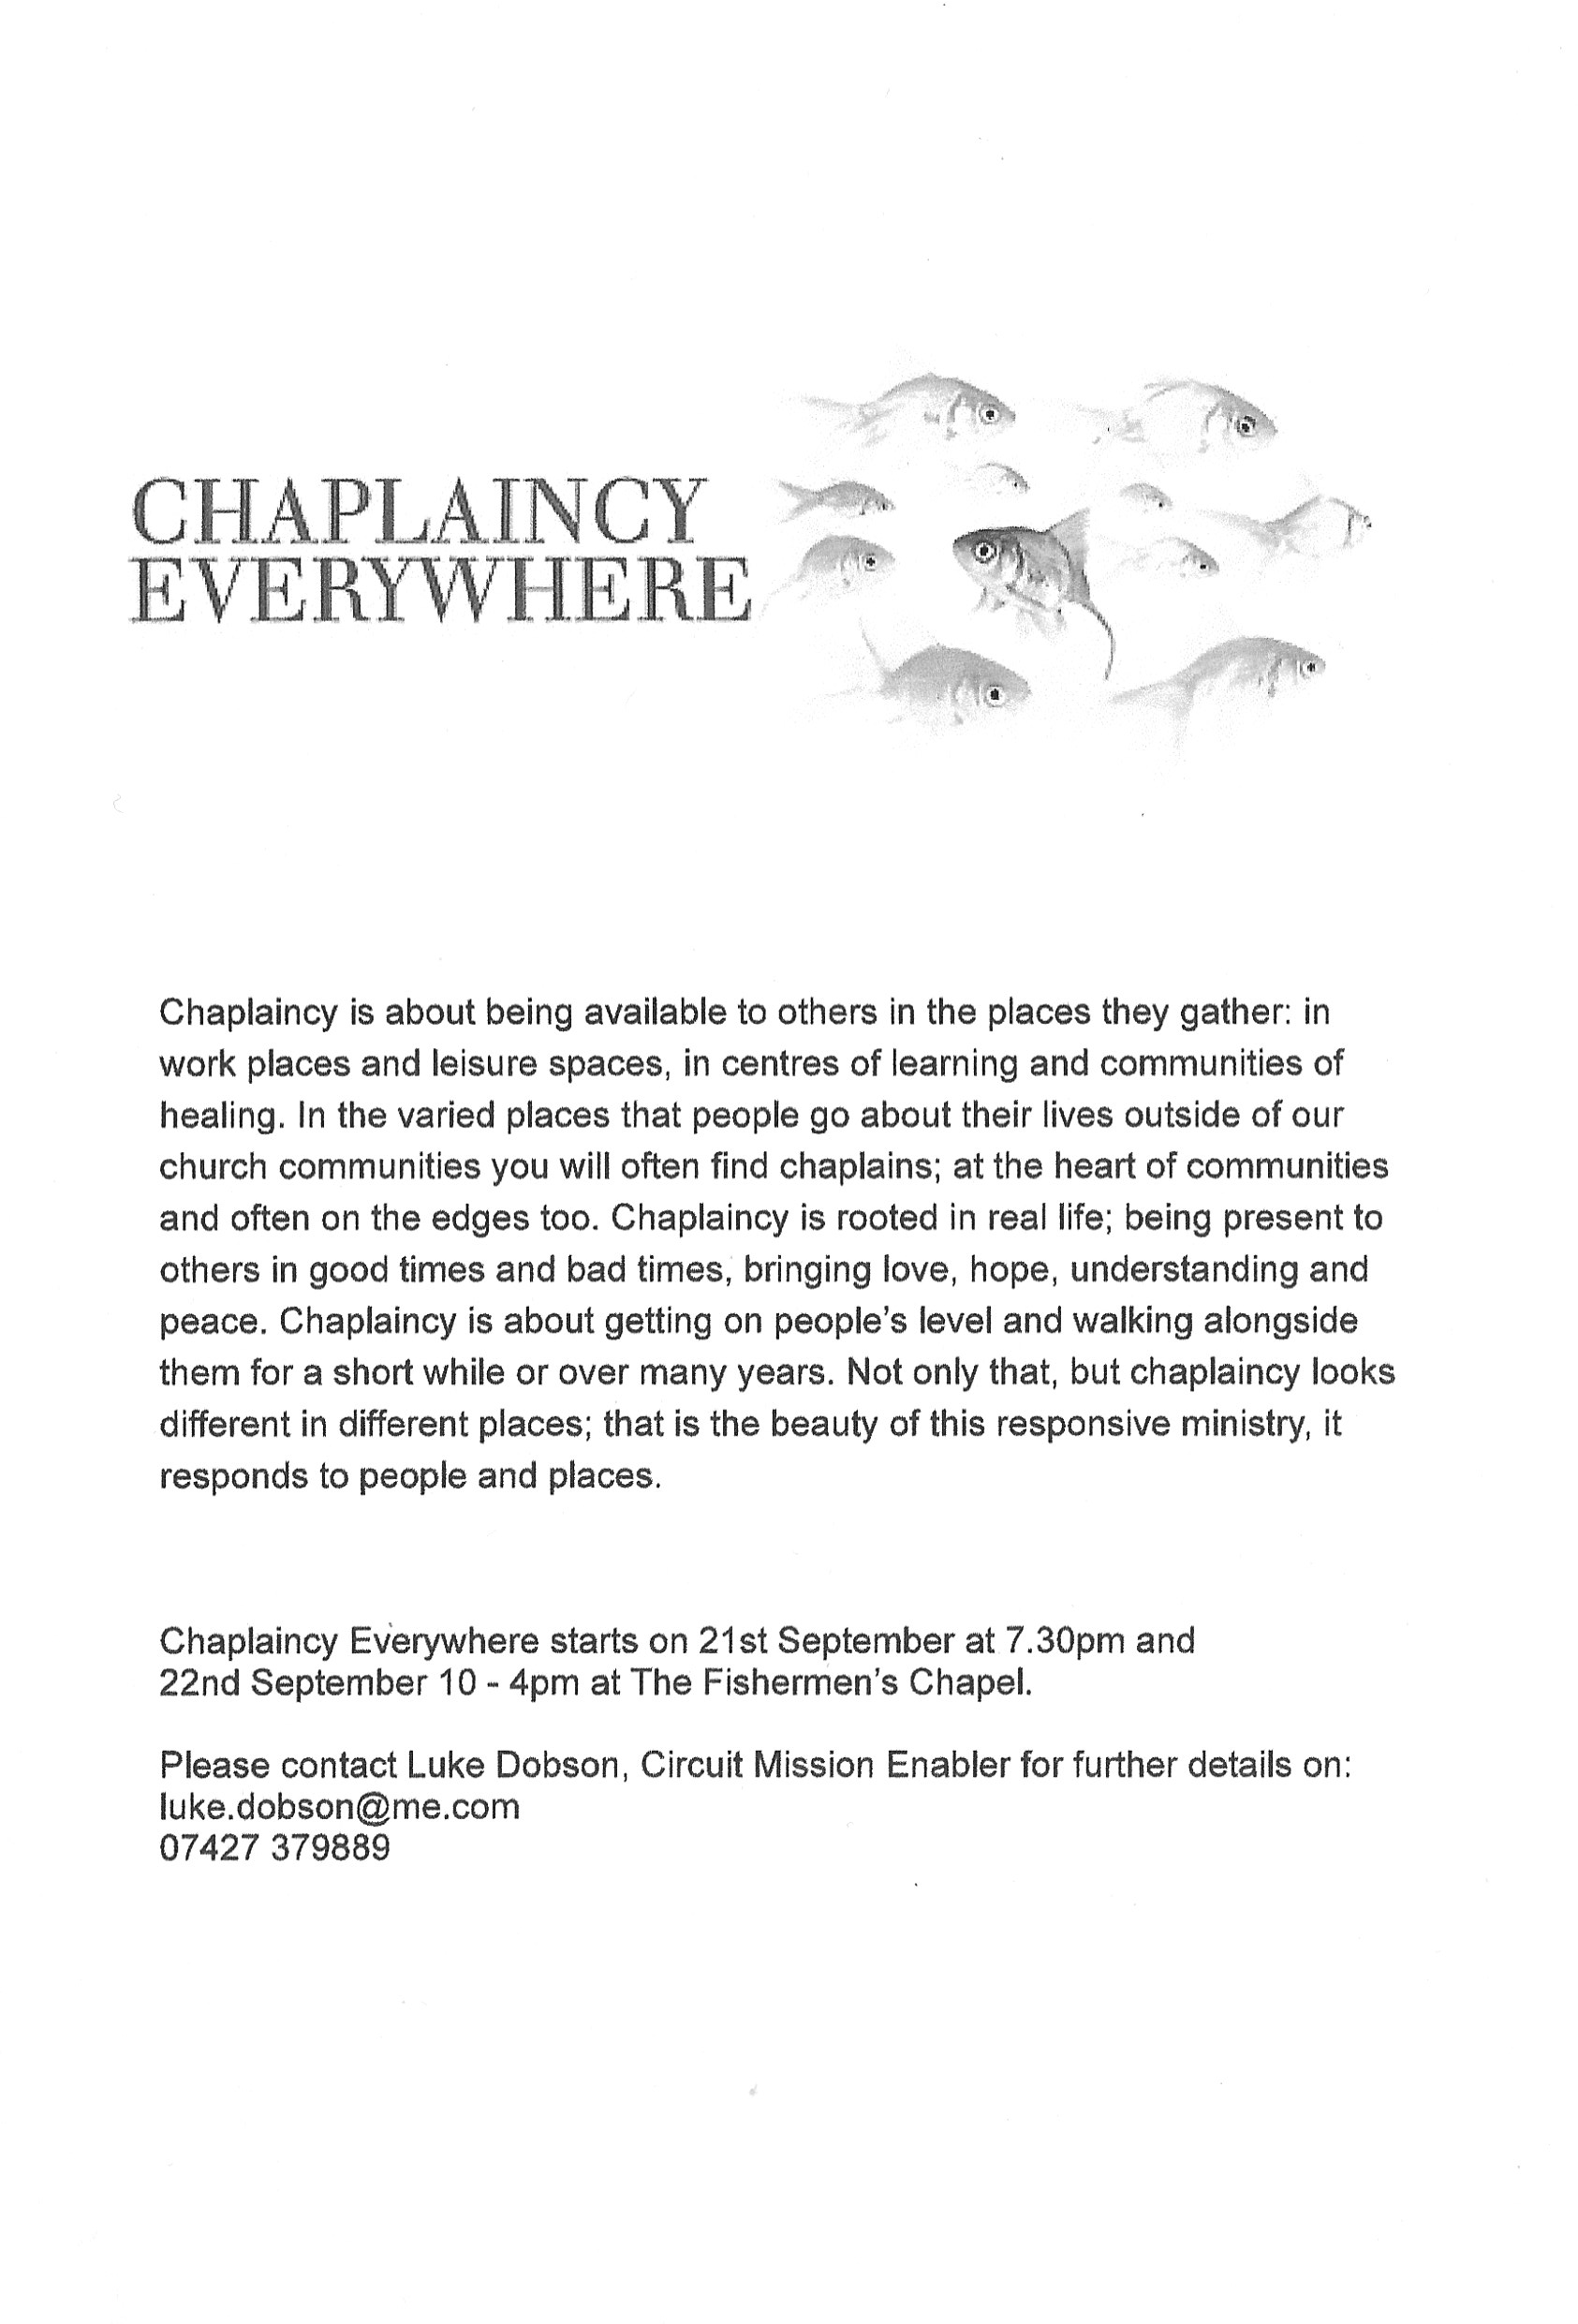

These words of mine were first written in 2010 and have been revised after this year's Methodist Conference reflecting on our President and Vice President's themes of radical grace and transferring hope and the work of the group Dignity and Worth
Deacon Eunice Atwood (Tutor at Queens Foundation Birmingham) 2018.

I want to be a part of the Methodist Church ..

I want to be a part of the Methodist Church that rejoices in God's radical grace.
A Church that celebrates the dignity and worth of every ethnicity, sexual orientation and gender identity.
A Church that challenges every form of discrimination.
A Church where true love truly casts out our fears.

I want to be a part of a Church that offers transforming hope.
A Church that confronts i8njustice and poverty.
A Church where all can know that they are valued and loved.
A Church which reflects the hospitality of a generous God.

I want to be part of a Church that is prayer-filled.
A Church that is resourced and sustained by the Bible.
A Church that can offer hope even in a crisis.
A Church that can live with diversity, difference and disagreement.

I want to be part of a Church that welcomes the wealthy, those who have power and influence.
A Church that knows how to party and celebrate life.
A Church that acknowledges death and boldly speaks of resurrection.
A Church that doesn't pretend to have all the answers but encourages all the questions.

I want to be part of a Church that throws parties for prostitutes.
A Church that welcomes those who seek asylum.
A Church that longs and yearns for justice.
A Church that listens to those no one else wants to listen to.

I want a Church that believes in transformation and not preservation.
A Church where those who are lost can be found.
A Church where people can discover friendship.
A Church where every person takes the responsibility in sharing the good news.
I want to be part of a Church whose hope is placed securely and confidently in transforming the love of God.
A Church that engages faith in its communities.
A Church that makes and nurtures disciples of Jesus.
A Church where the story of God's love is at the centre.

I want to be part of a Church that offers radical grace, transforming hope, unconditional love and engaging faith.

This is God's story. My prayer is that by the power of the Spirit of God at work amongst us, it will increasingly be our story.
Methodist Recorder July 2018

LADIES CLUB
Our programme for September is as follows:

5 September David Stanley
12 September AGM
19 September Alan Jasper
26 September Waitrose (1:00 pm)
3 October Harvest Lunch
Our meetings start at 1:45 pm unless otherwise stated.
Elizabeth Ellis

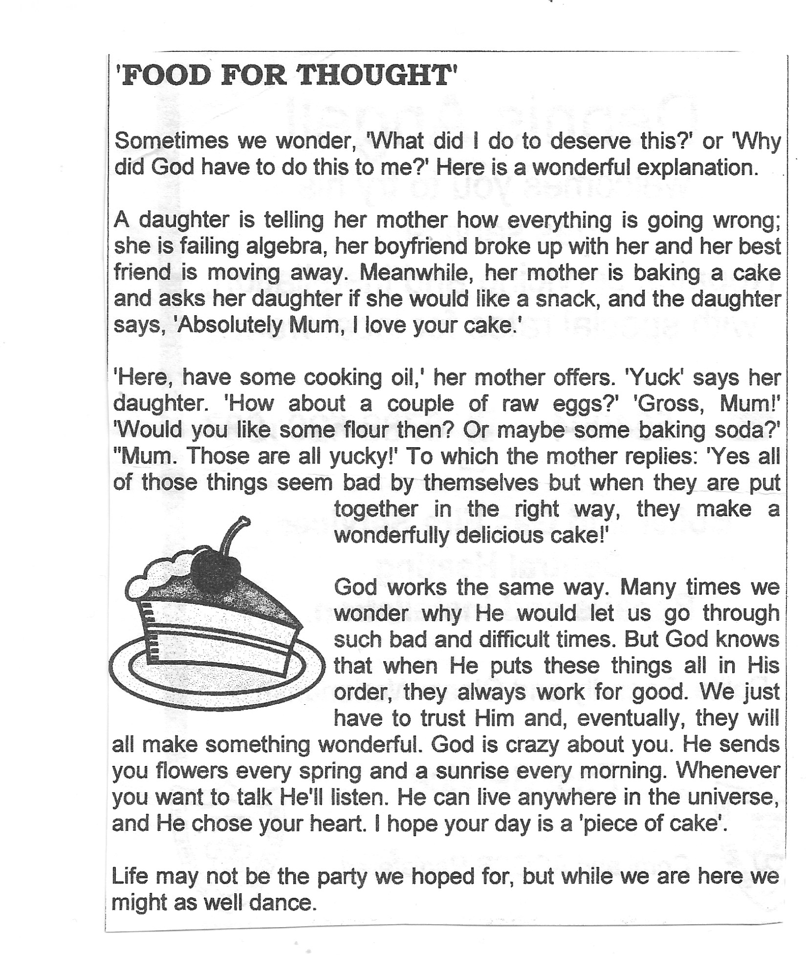
Hearing is not believing
A wise schoolteacher sent this note to all parents on the first day of school: ‘If you promise not to believe everything your child says happens at school, I’ll promise not to believe everything he or she says happens at home.’

What did we do before Google?
Google, the internet search company, was founded 20 years ago this month, on 4th September 1998, by Larry Page and Sergey Brin, both students at Stanford University in California. The company was initially based in a friend’s garage. The friend – Susan Wojcicki – is now CEO of YouTube.
The company developed from an idea for an innovative search engine originally called Backrub, which outshone early competitors. Eventually its use became so ubiquitous that the word “google” is now often used to mean search on a computer.
From the outset Google has included “Don’t be evil” in its code of conduct, and this has been reiterated as recently as this year. The company says: ‘We believe strongly that in the long term, we will be better served – as shareholders and in all other ways – by a company that does good things for the world even if we forgo some short-term gains.’
The name Google is a play on the mathematical expression for the number 1 followed by 100 zeros. It reflects the founders’ mission ‘to organise the world’s information and make it universally accessible and useful.’
The company’s huge campus, Googleplex is a tourist destination in the San Francisco Bay Area. It is regarded as an ideal employee-friendly workplace. The company employs over 60,000 people.

Best way to clean your house
The most efficient way to clean your house is to tackle it chore by chore, not room by room.
Dusting, vacuuming, and tidying room by room wastes time, according to the Good Housekeeping Institute (GHI). Instead, once the duster is out, go over the whole house with it. Follow the same procedure with the vacuum cleaner, mop, dustpan and brush, window cleaning gear and other cleaners.
Other good tips: keep a running list of ‘groceries to get’, put a damp sock on your hand to wipe the dust off of blinds, add dishwasher rinse to water to clean windows and leave them streak free

You are invited to our
COFFEE MORNING
for
AIR TRAINING CORPS
(Clifford Newman)
on
Saturday 15 September 2018
10.00 to 12.00 noon

It will include the following stalls, cakes cards, books, bric-a-brac,
and much more
DONATIONS FOR RAFFLE PRIZES WOULD BE APPRECIATED

Wesley Guild

We start our new season on Thursday 13th September. Meetings start at 8pm unless otherwise stated. Please come along and join us. We have some very interesting talks together with fellowship and fun.
13 September - Coffee Evening at Church
20 September – President's Address
Margaret Babbage
27 September – 'Medicine Through Time'
Vicky Gray
4 October - HARP
(7:30 Start) Lisa Watson
Margaret Flintham

Some musings on daily life Children seldom misquote you. In fact, they usually repeat word for word what you shouldn’t have said.
I don’t approve of political jokes…I’ve seen too many of them get elected.
I love being married. It’s so great to find that one special person you want to annoy for the rest of your life.
I married my wife for her looks…but not the ones she’s been giving me lately

SERVICES For This Month
[S] = Sacrament of Holy Communion [P] = Parade
[T] = Testimony Service by Rev Christopher Sandy prior to his ordination in July

'02 September | '8.30 | Rev Stephen Watts [S]
 | '10.45 | Rev Stephen Watts
'09 September | '10.45 | Danella Mayo
 | '18.30 | Rev Stephen Watts  Reflective Worship
'16 September | '10.45 | Rev Hannah Bucke [S]
'23 September | '10.45 | Jill Campbell
 | '18.30 | Rev Stephen Watts [S]
'30 September | '10.45 | HARVEST FESTIVAL  Rev Stephen Watts [P]
 | '16.00 | Rev Stephen Watts  Messy Church

HARVEST FESTIVAL
This year Harvest Sunday will be celebrated on 30 September. As usual, will be decorating the church and would appreciate your help in the form of donations towards the cost.
If you can help in this way, please put your donation in the retiring collection after morning service on 23 September.
Thanking you in advance. Margaret Babbage.

MID-WEEK COMMUNION
There is a mid-week communion in September but not October.
Mid-week Communion Sec

Bible Study at Clifford and Linda's house at 10am on Friday 28 September

A couple were thrilled after winning the Echo's Win a Wedding Competition.
Rayleigh's Claire Higgs and Michael Lorrimore beat off competition from eight other couples across the county with readers choosing them to win the incredible prizes on offer.
The pair are now looking forward to a £6000 wedding at Richwell Farm, with photographs, a wedding cake and a mini moon – a type of honeymoon – all paid for as part of the competition.
Claire, 46, said it was a dream come true for them both. She said: “I cant believe it. “Michael's mum nominated us for the competition and we have had people from her Methodist Church voting for us as well as family and friends. My work even got involved. I'll have to buy her a big cake to say thank you. It's great news to know that we have won.”
Claire and Michael were in the same class at the Fitzwimarc School, Rayleigh, but the pair were never more than acquaintances an when they left school went their separate ways.
Each got married, with Claire, having one child and Michael, three, before fate brought them together again.
Years later they reconnected when they met at a school reunion having both split up from their previous partners.
A date soon followed and Michael popped the question at a restaurant in Kent last year. Claire said “It was such a surprise and so beautiful. We were struggling to afford a wedding and now thanks to the Echo we can have one. We will be having an intimate affair and it will be very special. We are thinking about May next year: Thank you, Echo”
Claire and Michael secured 540 votes, securing first place. In addition to the venue, the pair also won a wedding dress, suit for the groom, a DJ and stationery to invite all their guests to their special day.Echo Head of Content, Gary Pearson, said: “We are delighted to be able to make their special day a dream come true for Claire and Michael and wish them a lifetime of happiness. Echo, Friday 6 July 2018

CHURCH FAMILY NEWS
Best wishes to Les Oatley, who is now home after several weeks in hospital both here and in London. We have missed him and hope to see him soon.
Keith Dann is making progress following a recent fall. He and Marion wish to express thanks for prayers, cards, help and good wishes they have received.
We hope that Roy Miatt and Janet Warner are now fit after the summer break.
Loving sympathy goes to Richard and Jo O'Shea following the death of Richard's mother a few weeks ago.
Congratulations to George Flintham, grandson of Margaret and Keith on gaining his Degree in American Studies from Groningen University in Holland. He hopes to be working in London.
Michael Lorrimore and his fiancee Claire appeared in a local newspaper when they won a competition for help with their forthcoming wedding, receiving the most votes thanks to support from family and friends, including several from the church. Well done.
Are there any special anniversaries or exam results to report ? Please send in news.
Happy New Methodist Year.
Val Tyler

RAYLEIGH METHODIST CHURCH
PRAYER GROUP MEETING DATES 2018

SEPTEMBER: 5th & 16th
OCTOBER: 3rd, 17th, & 31st
NOVEMBER: 14th & 28th
DECEMBER: 12th
ALL MEETINGS ARE IN THE WELCOME AREA, COMMENCING AT 9.30AM, FOR ABOUT 45 MINUTES.

FROM THE EDITORS WE NEED YOUR ARTICLES for the October 2018 EDITION
The deadline for the submission of articles for this edition of the Newsletter is Sunday 9 September 2018 ( in Welcome Area) or Wednesday 12 September by post or email. John and Sue
johnward816@gmail.com

Sunday Services
Morning Worship: 10:45 am
Reflective Worship: 6:30 pm on 2nd Sunday of the month
Messy Church: 4:00 pm on last Sunday of every month (except August)
Junior Church: 10:45 am (except August)

Mid-Week Communion
With the exception of August it is held on the third Tuesday of each month in the WESLEY ROOM at 10:30 am.

REGULAR WEEKLY MEETINGS
Monday
1:15pm Sunbeams Parent and Toddler Group
2:30 pm Women's Fellowship

Wednesday
1:45pm – 3:15pm Ladies Club
4:15 pm-5:30 pm Rainbows
5:45 pm -7:15 pm Brownie Guides
7:00 pm-8.45pm Guides

Thursday
10:00 am Care and Share
5.15 pm- 6.15pm Beavers
6:30 pm - 7:45 pm Cubs
8:00 pm – 9:30pm Scouts
8:00 pm Wesley Guild (Sept to May only)

Friday
4:30 pm-5:45 pm Rainbows
5:30 pm-7:00 pm Brownie Guides
7:15 pm -9:00 pm Guides
7:15 pm -9:00 pm Guides Senior Section (fortnightly)
Preschool
Mon 9:15 am to 11:45 am
Tues Weds Thurs Friday 9:15-11:45 am and 12:30-3:00 pm

Editors John and Sue Ward 9 Sheridan Close Rayleigh SS6 8YR Telephone 01268 742847 (johnward816@gmail.com)
9

