**RAYLEIGH**

**METHODIST**

**CHURCH**

Eastwood Road

Rayleigh SS6 7JP

**Minister** Rev. Phil Warrey 01268 770333

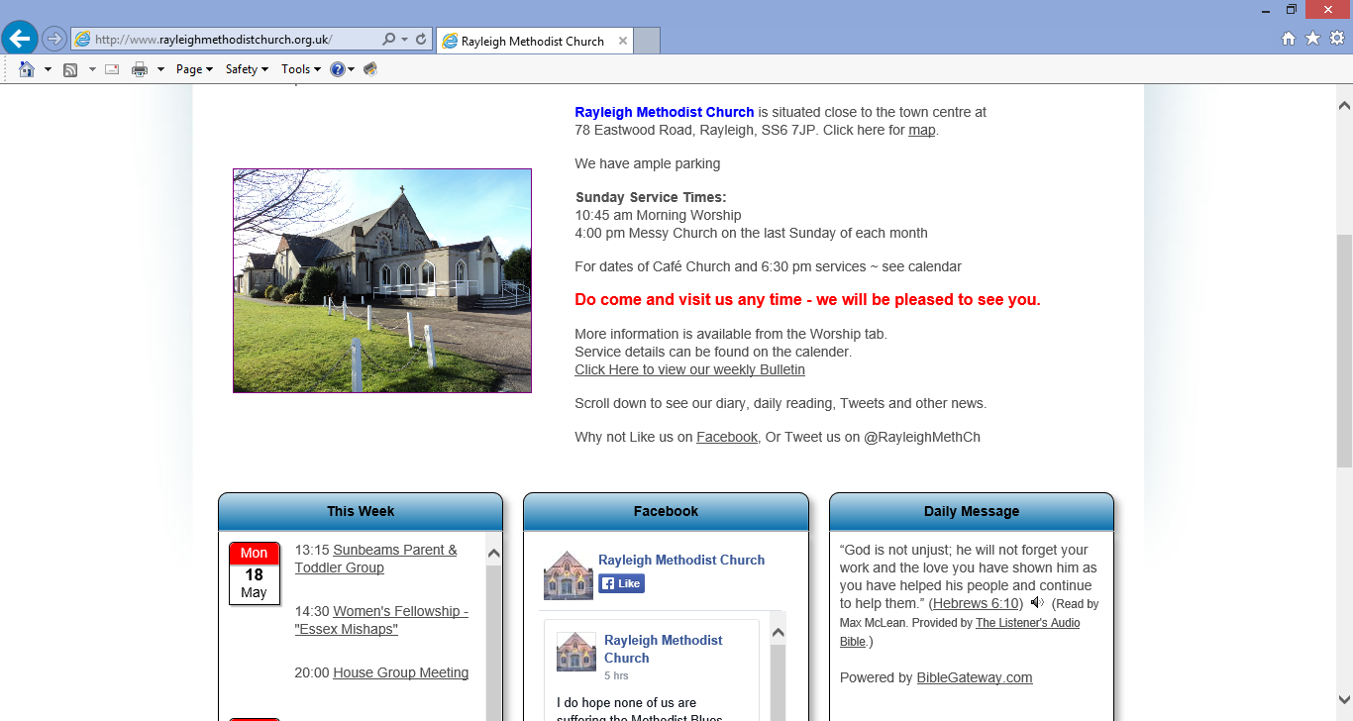

**THE NEWSLETTER**

**FEBRUARY 2017**

**FROM THE MINISTER**

As I write this we are coming out of the season of Epiphany, and waving goodbye to the Wise Men. Christmas has been well and truly packed away, and it is cold and miserable outside. The pound is falling, Brexit is approaching fast, and the world seems to be going mad. President Trump is about to be inaugurated, I think I will stay under the duvet till the summer!

I must take an opportunity to thank everyone for their Christmas cards and their good wishes whilst I was not well. I did manage to limp through everything, even if I did go straight back to bed on New Year’s Day straight after the morning service. We gave up this year on sending any Christmas Cards at all, we just ran out of time – interestingly it felt quite liberating.

Back to the world, or at least the small part of the world I can see from under the duvet! It’s warm in here, I may never come out again!

We’ve faced all this doom and gloom before, some of you have lived through much worse times. It’s times like this that we need to be reminded of our faith, and of our God, and Jesus who loves us, and is our salvation. Let’s give thanks for our faith, and encourage each other, and at least love each other, and those we meet despite what the world is doing around us.

Also, a great part of our faith and our life with God, is always knowing that because of God, and because of his love for us, and because of his promises of his kingdom coming there is always a hope. We have this hope as an anchor for the soul, firm and secure (Hebrews 6:19)

I was very encouraged by the response at our Holiness and Justice service on New Year’s Day. Roger and Rachel have this year reminded us that we as Methodists have something distinctive to offer to the world. If you want to follow their travels, and read more of what they have to offer then there is the new edition of the Connexion magazine in our churches, and you can follow them on <http://www.methodist.org.uk/news-and-events/leadership-blogs>

We have reflected recently on the rules of the Holy Club, of our founder John and his brother Charles and their friends when at Oxford. In their rules, they agreed to meet to pray, and to study the bible, to worship and to serve their community. Recently we’ve been identifying new ways to serve our communities, and Rayleigh has started to run a Breakfast club in partnership with the Children’s Centre on a Monday morning. Now, we are providing Tea and Toast, from February, we will be offering a cooked breakfast. Please continue to pray for us and speak to me or Pat Norman if you want to join the team.

As well as serving our community, it will be via the children’s work and meeting children and parents that we have our best opportunities to draw people into the life of the church. It is no longer enough to open our doors on a Sunday morning and hope people will come. We need to build relationships with people, and encourage

them gently into the life and community of the church. At the moment, we are nurturing a vision for possibly employing a Children, Youth and Community worker between UMC, Hockley & Rayleigh. Please pray that we can find the right grants to enable this work.

You will be aware that we have not yet been matched with a new minister to replace me in September. Stationing has not yet come to an end, and we may yet be matched, however, it is now looking less likely, so we are working with Pete Moorhouse on a Plan B for 2017/18. Again, please pray for the right person to be found or a good Plan B to come to fruition. (For anyone who may want to say “Can’t you stay?”, unfortunately once the wheels of Methodist Stationing have started moving and you have committed to move, there is no going back).

Finally, another opportunity for prayer is the small group of volunteers that are attending the Rayleigh “Yoga, Mind Body and Soul Show” at Rayleigh Mill on 5th February. Howard Gardner and a small team, including some Rayleigh folks (and maybe me for a short time), are having a stall at the event. Research shows that many people who have turned their backs to mainstream Christianity are seeking other forms of spirituality. The team are having a stall called “Journey into Wholeness”, and use a deck of cards called “The Jesus Deck”, to engage with those who are spiritual seekers and help them reflect on Jesus story. I have been to a short training course, and have my own Jesus Deck. So please pray for the team as we engage and tell of the love of Jesus.

So chin up, you can come out from under the duvet, the light at the end of the tunnel is still on, despite what the newspapers and media are threatening. God is still our God, and we are still his people. Keep up the moving and travelling on, for we are the people of God.

Every Blessing

Phil

**WHEN FAITH GETS SHAKEN**

with Patrick Regan OBE (Founder and CEO of XLP) and Andy Flannagan (Singer/ Song Writer)

**Saturday 1 April**

**7: 30 pm**

**at the Megacentre Rayleigh**

Book your free ticket @ WWW. MEGACENTRE RAYLEIGH.C).UK

*(“A moving story of courage and faith in the fire”* - Bear Grylis, adventurer, writer and TV presenter)

**WOMENS FELLOWSHIP**

Our programme for February is as follows:

6th  Speaker - Jeanne Stafford

         "My life as a  Magistrate"

13th  Speakers  Linda Newman & Dilys Hand

         Women's World Day of Prayer

20th Speaker  - Clive Lewis

          "Gospel Grooves"

27th  Speaker - Jean Nightingale

          "Dates"

All ladies are welcome to our Monday afternoon meeting. We commence at 2:30 pm.

Elaine Blades

**WOMEN’S WORLD DAY OF PRAYER**

A worldwide Movement of Christian women of many traditions who come together to observe a common day of prayer and worship on the first Friday in March each Year.

This is a multi-denominational service for all.

This year’s service is to take place at Holy Trinity on Friday 3rd March at 1.30pm.

All are welcome to this service of prayer, praise and reading. This year’s service has been put together by the women of the Philippines.

The theme is ‘Am I Being Unfair to You?’ – ‘We will offer our hands to plant, nurture and harvest’

The service lasts for about 1 hour and is followed by light refreshments.

If you would like more information about WWDP please look at the website [www.wwdp.org.uk](http://www.wwdp.org.uk/#_blank)

Would you please advertise this service within your Church -  I have attached a poster for you to print -and if any more information is needed please do not hesitate to contact me on [phg7782@gmail.com](mailto:phg7782@gmail.com#_blank)  or 01268 750324

It would be helpful to know if there are going to be any young children attending as we can provide some activities for them.

Mrs Penelope Gendall

Secretary for Rayleigh WWDP

**CHURCH FAMILY**

Birthday greetings to Mrs. Elsie McKinnon who will celebrate her 90th  
birthday on February 3rd. Much love goes to her.

John and Sue Ward are proud to announce the birth of their first grandson, Sunny, to Rachel and Michael, born on 15 December. This was a double celebration as Rachel and Michael were married on 28 December.

Joyce Tyler has a new great-grandson with the birth of Diego Val on  
November 18th to Bryan and Alexia.  He was Joyce's 11th great-grandchild.

We also celebrate the birth of Elise Valerie on December 30th to Shona and Alex.

Welcome to all these new babies.  
   
We shall soon be saying goodbye to Fran and Richard (Sunny) Sunderland  
and their daughter Mia, who are moving to Cambridge.  They will be  
missed from our church family but we wish them well.

Also missed will be our friend Mr. Clifford Wilkinson, who passed away recently. Sympathy goes to his family.

Val Tyler

**Coffee Morning**

**18 February 2017**

**10am-12noon**

**Organised by The GUILD**

**It will include the following stalls, cakes cards, books, bric-a-brac,**

**and many more**

**All welcome, please come along and support us**



**Large Tea Bags**

I’ve been meaning to mention that we now have available in stock in the church supplies cupboard large 4 pint tea bags. These traditional catering tea bags are designed to ease the preparation of tea for large numbers. The ideas is that you put one in the large teapots. Fill the tea pot with water. Stir, leave brew for 2-3 minutes, test the strength of the tea, and when you are happy remove the tea bag. This means the Tea no longer stews or gets stronger, and pouring of the tea is not impeded by loads of little tea bags blocking the spout. This may take some getting used to, but it does work! Also for those serving drinks, please note we have a full range of Tea, Decaff Tea, Green Tea, Coffee, Decaff Coffee and Hot Chocolate. If you wish to learn to use the Coffee percolator when you need 40-100 cups of coffee, please ask.

**Megacentre Rayleigh Programmes and Services**

**Youth Work Team (10-19 Year Olds)**

Overseen by Full Time Youth Development Worker

Transitions Youth Club:

Open access club running on Monday evenings for young people in school years 6 & 7. Focus is to support young people through the move from primary to secondary education. Young people referred by schools, have siblings in other sessions, hear about the project through centre advertising or word of mouth. Currently supports 15-20 young people with capacity for up to 25. Further links to schools for follow up work developing.

Open Youth Club:

Open access club running on Tuesday evening for young people in school year 8+. Provides a safe environment, positive activities, advice and support. Young people come from a variety of backgrounds. Key issues include relationships, identity, sexual health, risk taking behaviour mental health, positive activities and healthy lifestyles. Currently supporting 30-35 young people.

Be Project:

A fortnightly programme for young women running from the Silver Spoon café in Rayleigh. Gives young women a safe, supportive space to explore identity, purpose, value and worth. Aims to combat unhealthy relationships, self harm, poor mental health and develop confidence, resilience and ambition. Currently supports 12 young women, but growing, with capacity for 20-25.

XL Mentoring:

In partnership with Youth Worker at URC church, XLM recruits community mentors and pairs them with young people referred from local schools who would benefit from support. Minimum engagement is 1 year, so this is a big commitment project for both mentor and young person. In early stages with 5 young people currently supported, but will grow over the coming months.

Schools Support:

Engagement with schools to provide support to students struggling with mainstream education or at risk of hidden harm. Projects tend to be short term, and have included confidence building, resilience development, CSE awareness and prevention, attainment and engagement.

Dads and Kids Club:

A Saturday morning club offering time for Dads with Kids aged 5-13 to meet together, play together and share together.

**Family Support Team**

Overseen by 1 Full Time and 1 Part Time Family Support Worker

Individual Family Support:

1-2-1 supporting for approximately 30 families across Rochford and Castle Point. Supporting families through domestic crisis, bereavement, debt and benefits, parenting issues etc. Family referred from other sessions or through schools, social care, children’s centres or family solutions.

Family Fun Sessions:

Weekly activity club for children with additional need and their parents and siblings. Provides respite and positive activities including arts, games, music and exclusive use of soft play facility and sensory room. Currently supporting approximately 25 young people (along with parents)

Parentalk Parenting Programme:

A six-session programme giving parents to chance to exploring parenting skills together. Sessions are very collaborative and explore issues such as behaviour and boundaries, communication, independence. 2 different courses are run (Primary and Secondary age focused) between 4 and 6 times a year. Courses support 8-10 parents.

SEN Forum:

Monthly meeting for parents of young people with Special Educational Need. Provides space to share experiences and each session have a clear focus. Currently support 16 parents

ADHD Forum:

As SEN Forum, but specifically focused on ADHD. Partnered with Family Solutions and includes guest speakers when available. Supports 12 parents.

Twins and More:

A support group for multiple birth parents and their children. A social group for shared experience – also includes soft play access. Original group taken on from Children’s Centre, but growing with word of mouth and MegaCentre users. Supporting 10-12 parents (plus 20-24 kids!)

Freedom Programme:

Both Family Support Workers recently trained to deliver the Freedom programme support women leaving or coping with domestic abuse. Plans to run programmes from January 2017.

Wider Centre Work

Soft Play Activities:

The MegaCentre Rayleigh soft play facility, known as Megaplay, is a super exciting place where children can play, explore and learn in a safe and fun environment that encourages their physical, social, emotional and intellectual development.

The benefits of soft play are well documented:

1. Encouraging active play
2. Learning through exploring a fun environment
3. Using imagination and exploration to learn confidence and independence
4. Trying new activities and achieving new skills
5. Developing new motor skills and problems solving through exploration

Sensory Play Programme:

Utilising the centre’s Sensory Room, our Sensory Play sessions focus on development in the early years for children from 6 weeks and up. Some benefits of using the sensory room are:

1. Hand to eye co-ordination as little eyes track lights and bubbles
2. Colour and shape recognition
3. Gross and fine motor skills through playing with toys
4. Cause and Effect through interaction with equipment that responds
5. Speech and Language development through exploration
6. Baby-parent bonding through session activities and calming environment

Over 50s Sports:

3 sessions per week offering different sports including short mat bowls, badminton, table tennis. Nominal entry fee applies.

Room Hire:

Used by multiple community groups including dance, drama and community music.

Social Enterprise:

Our commercial operations are not-for-profit with all income supporting our running costs and community programmes. The social enterprise employs approximately 50 16-21 year olds in part time work and provides recreational facilities to over 1000 families each week.



**Church Officers**

As you are aware we will be looking for 3 new stewards to replace our outgoing stewards in May. Nomination papers for new stewards will be available in the Welcome area shortly. Please complete and pass to one of our stewards or to Phil. We are also looking for a replacement Property Steward, as John offered to serve for one additional year, and that is coming to an end. We do not need paper nominations for Property Steward, just have a word with John, one of the stewards or Phil. Please pray that we can find the right people to be new church officers. (Of course, there is a danger to that prayer because as you pray it, you may realise that they right person maybe you!)

**“Away in a Manger”**

The following version of this popular carol was written by Don Babbage. It was sung by the congregation at both Christmas Eve Services. It certainly puts things into perspective, I decided to include it in the Newsletter for the benefit of those who have never sung or heard it.

Janet Warner

At night in a doorway, a box for a bed,

A cold, hungry Jesus laid down his sad head.

The rain from the grey sky teemed down where he lay,

The rough sleeper Jesus awaits Christmas Day.

The store fronts are loaded with presents galore,

There’s turkey and pudding at your local store.

The fam’ly is coming to spend Christmas Day

To eat and to drink and give presents away.

The cop on patrol gives Jesus a shake.

“Come on, now then, matey, it’s time to awake”

“Move on from this doorway, you really can’t stay

Go find somewhere else to spend your Christmas Day”

**WESLEY GUILD**

Following the Christmas break we recommence our regular Thursday meetings in February

2 February   "Mary’s Meals"

               Jane Brown

9 February  "The Methodist Art Collection"

                   Rev. Clifford Newman.

16 February  An Evening with Vicky Gray.

18 February.(Saturday)

Guild Coffee Morning 10 to 12Noon.

23 February  An evening with Eddie and John

Everybody welcome to join us on Thursdays at 8pm

I will be grateful for offers of help and contributions for our coffee morning on the 18th.

Pat Oatley

1. **SERVICES FOR February**
2. **[S] = Sacrament of Holy Communion [P] = Parade**
3. **[B] = Infant Baptism**

|  |  |  |
| --- | --- | --- |
| 5th February |  |  |
| 10.45 am | Local Arrangement Theme Preaching |
| 12th February | 10.45 am | Rev Phil Warrey [P] |
| 4.00 pm | Rev Phil Warrey Café Church |
| 19th February | 10.45 am | Andrew Thomas |
|  |  |
| 26th February | 6.00 pm | Rev Brian Gameson [S] |
| 23.30 pm | Rev Phil Warrey Messy Church |

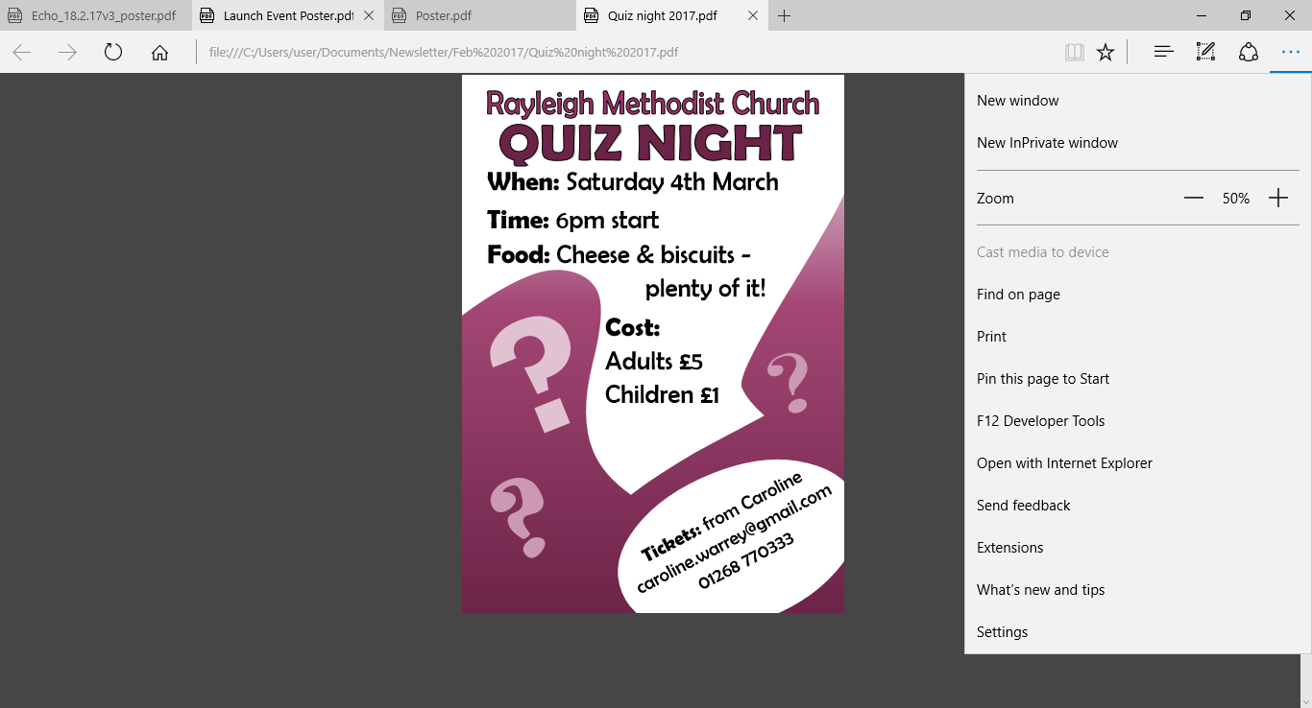

1. **RAYLEIGH METHODIST CHURCH**
2. **PRAYER GROUP MEETING DATES**
3. **2017;**
4. FEBRUARY: 8th & 22nd
5. MARCH: 8th & 22nd
6. ***ALL MEETINGS ARE ON***
7. ***WEDNESDAYS, COMMENCING***
8. ***AT 9.30AM, FOR ABOUT 45MINS.***
9. **FROM THE EDITORS WE NEED YOUR ARTICLES**
10. **March 2017 EDITION**
11. *The deadline for this edition of the Newsletter is Sunday 12 February 2017 ( in Welcome Area) or Wednesday 15 February (through our letter box or by email).*
12. [***johnward816@gmail.com***](mailto:johnward816@gmail.com)

**BIBLE STUDY**

Bible Study at Clifford and Linda's house (01268 784402 for details) - 10am Friday 24th February - 1 Timothy Chapters 3 and 4

**LADIES CLUB**

Our programme for the forthcoming weeks:

1 February - Topic of the Month

Elizabeth Ellis

**For Sale**

I have an Acer Aspire One notebook  computer surplus to requirements:

10.1" screen, Windows 7, 1GB Ram, 160GB storage.

If its of any use to you for £10 into the collection, let me know.

Don Babbage 01268 7848364