RAYLEIGH METHODIST CHURCH

Eastwood Road, Rayleigh
Minister
Rev Dr Calvin Samuel
Coordinating Steward
Mrs Pat Norman 01268 781896

THE NEWSLETTER

SEPTEMBER 2019

Dear Friends
I grew up in the Caribbean island of Antigua. It’s an island known for its delightful weather and 365 white sandy beaches. It’s also produced one or two world class cricketers: Viv Richards, Richie Richardson, Curtley Ambrose to name a few. Plus, if you enjoyed listening to world class cellist Sheku Kanneh-Mason at Prince Harry and Megan’s wedding last year, you can thank Antigua for that as his Dad’s Antiguan. It really is a magical place. If you’ve never been please go at once. Seriously, stop reading. Go now!
My family were 4th generation members of the Wesleyan Church, which split from the Episcopal Methodist Church in the United States over the issue of Methodist bishops who owned slaves. This was in 1843. As a consequence, despite the passage of time growing up I was always a wee bit suspicious of Methodists. Such is the power of institutional memory!
I came to faith as a teenager and was baptised at 16. I was fortunate enough to discover the Inter School Christian Fellowship which provided a nurturing place for young people to find and grow in faith. It also provided me with my first exposure to ecumenical partnership as I was discipled alongside young Christians from a wide range of denominations.
At 18 I went to work having failed most of my A Levels, and a year later took up a job in banking where I worked for the next 5 years. At 21 I felt called to ministry and spent the next 3 years building up savings as Wesleyan ministerial students are expected to be self-funding. I was recommended for training Britain.
So, I arrived in sunny Manchester in September 1993 expecting to train for ministry for 4 years after which I would be on the first aeroplane back to the Caribbean. 26 years later, here I am arriving in Southend & Leigh. Clearly, things have not gone according to plan….
The first sign that things were not going according to plan, at least not my plan, was a deepening sense of call to theological education. This required postgraduate studies after my initial 4 years of ministerial training. For a man who’d failed his A Levels postgraduate study was neither a conceivable nor welcomed prospect.
The second development was that I fell in love, with a girl called Ramona, at the end of my first year of training. Ramona is key to this journey because in our first year of marriage she was appointed to a Methodist Church as a layworker, which
1
began our journey into Methodism over several years. We married at the end of my third year and 2 years later our first child, Tiana, arrived. I was a postgraduate student by this point. 2 years after that our second child, Fletcher arrived. They are now 21 and 19. I’m not allowed to say how old Ramona is….
I was a Wesleyan minister from 1997—2000 and in September 2000 was appointed to a Methodist probationer appointment in South West London. At the 2001 Conference I transferred into Methodist ministry, was received into full Connexion, and ordained. Later that same year I received Connexional support to begin PhD studies alongside full-time ministry. It was a fairly challenging time, juggling circuit responsibilities, 2 young children and part time PhD studies.
In 2005 I completed my probationer appointment and was stationed to a part time school chaplaincy at Farringtons, a Methodist Independent School in Chislehurst, alongside a part time teaching post at Spurgeon’s College, a Baptist Theological College in South Norwood, near Croydon. Whilst in this appointment I completed PhD studies.
In 2010, I was stationed to Durham as Director of the Wesley Study Centre, the Methodist Theological College serving the North East of England. Durham was a great place for us as a family, and our children in particular enjoyed the difference in lifestyle from London. Whilst in Durham, Ramona candidated for diaconal ministry, completed ministerial training in York, and was stationed to her probationer appointment.
Over the last 5 years, I’ve been in appointments outside the control of the Connexion. From 2014 to 2016 I served as Academic Dean of St John’s College, Durham University and from 2017 to 2019 as Principal of London School of Theology.
I’m a petrolhead, so I love cars and most things car related and dream of a day when my budget will match my ‘car-spirations.’ I’m a huge fan of Formula 1 racing. I sincerely hope there will be cars in heaven….
I love singing and music, and still plan to learn a musical instrument when I grow up.
I’m very much looking forward to getting to know you in the coming weeks and months and am full of anticipation about what we will accomplish together under God.
All God’s Blessings. Calvin.
2

CHURCH FAMILY NEWS

With sadness the death is announced of Les Oatley, a longstanding and much loved member of this church, who served in many capacities from the days of his youth to the present day. Loving sympathy goes to Pat and all the family.
The death of David Stubbington occurred following an illness borne
with stoicism. His mother Betty and all the family are in our thoughts
and prayers. David will be missed on the bookstall at coffee mornings.
Good wishes are sent to Peter Lewis, who has been ill during the summer.
Congratulations to Brian and Judith Ring who celebrated their Diamond Wedding Anniversary in August.
Birthday greetings to Eileen Morgan who will be 90 on September 3rd. She is making progress after a spell in hospital.
News from proud grandparents:
Janet and Tony Warner's granddaughter Elise completed her 2-year
Public Service Course at Seevic with good grades and is now working at Daws Heath Kennels.
Sheila Cooper's granddaughter Daisy gained a 1st Class Honours Degree in Interior Design and is working for the Kelly Hoppen Company.
My youngest grandson Peter has gained a good B.Eng Degree from
Swansea University.
Well done to all for their achievements. I'm sorry if anyone has been missed - please remember to send in your news.
Congratulations to Linda and Clifford Newman on the birth of their granddaughter Freya Jane Newman, 6lb 8oz. to Kimberley and Martin. Best wishes to Linda Newman who is had an operation on her hip on Monday 19th August.
Finally, Lorraine Mann is asking for (empty) crisp packets which she is
collecting for Guide Dogs. Please save them for her.

Val Tyler
3

SERVICES FOR JULY AND AUGUST 2019
'1 September | '9:30 | HC | Rev Michael Moon
'1 September | '10.45 | W | Local Arrangement
'1 September | '18.00 | Welcome* | Rev Peter Moorhouse
'8 September | '10.45 | W | Rev Gordon Bates
'8 September | '16.30 | RW | REV Dr Calvin Samuel
'15 September | '10.45 | HC | REV Dr Calvin Samuel
'22 September | '10.45 | W | Sue Hockett
'22 September | '16.30 | HC | REV Dr Calvin Samuel
'29 September | '10.45 | HF | Rev Peter Moorhouse
'29 September | '16.00 | Messy Church | Local Arrangement

P PARADE HC HOLY COMMUNION W WORSHIP RW REFLECTIVE WORSHIP JCA JUNIOR CHURCH ANNIVERSARY
*Welcome Service for Rev Dr Calvin Samuel

WOMEN'S FELLOWSHIP PROGRAMME FOR SEPTEMBER 2019
9 September Welcome Back Social
16 September Speaker Jamie Sawtell
"The Mega Centre"
23 September Speaker Keith Lovell
"History Through Famous People of Essex"
30 September Members Afternoon
Elaine Blades

4

ALL IN THE MONTH OF SEPTEMBER
It was:
500 years ago, from 20th Sept 1519 to 1522 that Portuguese explorer Ferdinand Magellan led a Spanish expedition to the East Indies. It became the first circumnavigation of the world. But Magellan was killed in a battle with natives in the Philippines in 1521.
125 years ago, on 1st Sept 1894 that the General Post Office in the UK sanctioned the use of picture postcards and introduced a half-penny postage rate for them. This led to a boom in picture postcards and the extensive photographic documentation of towns and landscapes.
Also 125 years ago, on 28th Sept 1894 that the British retail chain Marks and Spencer was founded when Michael Marks acquired his first permanent stall in Leeds covered market and invited Thomas Spencer to become his business partner.
65 years ago, on 29th Sep 1954 that CERN (the European Organization for Nuclear Research) was established in Geneva Switzerland.
40 years ago, on 29th Sept 1979 that Pope John Paul II became the first pope to visit Ireland.
15 years ago, from 1st to 3rd Sept, that the Beslan school hostage crisis took place in Russia. Armed terrorists took more than 1,100 children and adults hostage. Russian security forces ended the crisis on the third day, entering the school with tanks and heavy weapons. More than 300 hostages were killed, including 186 children, and hundreds more were injured.
Also 15 years ago, on 30th Sept 2004 that the Iraq Survey Group released its final report (the Duelfer Report) on Iraq’s purported weapons of mass destruction programme, following the 2003 invasion of Iraq. It concluded that Iraq had not had any weapons of mass destruction since 1991.
10 years ago, on 14th Sept 2009 that Keith Floyd, the British celebrity cook, television presenter, restauranteur and writer, died.

THE LADIES CLUB
Our programme for the next few weeks is as follows:
11 September AGM
18 September Peter Lazyell -
When Policemen still had feet
25 September Macular dystrophy
2 October Doreen Sims
Guide Dogs
Elizabeth Ellis
5

CONGRATULATIONS
To Eileen Trayling who celebrated her 100th Birthday on Thursday 15 August.
Eileen who still lives at home celebrated this wonderful occasion with her friends from Rayleigh Methodist Church's Womens Fellowship and Care and Share Group. She was presented with a beautiful bouquet from the Members and Friends of the Church.
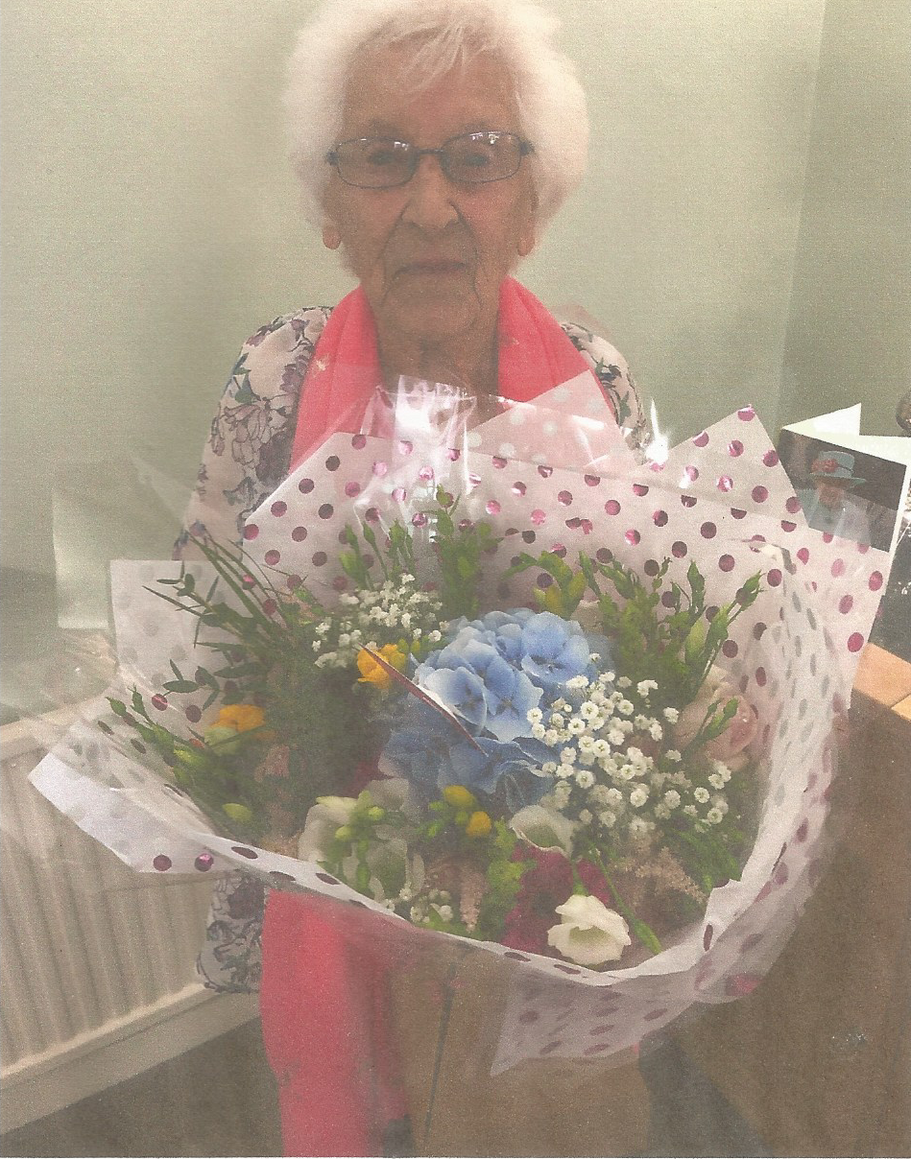Eileen was delighted to received a signed telegram and card from Queen.
Eileen was born in Rochford and later moved to Ashingdon which meant she had to walk to Rochford School. She is the oldest of four children. One of her earliest memories was that she had to take sandwiches to school and there no free milk.
Her father worked for the Gas Light and Coke Company on the two holders that were in Progress Road. He was also a water diviner and found springs from which the family drank water.
Eileen left school at fourteen and worked as a machinist, and she made parachutes for the war effort.
Her husband, Arthur, who she met just before the second world war was conscripted to the Essex Regiment when he was 20. He served at Dunkirk, in Italy and Greece. They married in 1941 at Holy Trinity Church Rayleigh when he had a 48 hour pass. She never saw him for another two years.
6
When asked when you look back on your life would you change anything, she answered, “No,I have a lovely family and great friends and have always been contented with life”.
To the question, “What was the best decade for you?”, she replied, “40's excluding the war.”
Her Favourite holiday was a cruise visiting Greece and the Greek islands, a memorable part being walking up to the Acropolis at Athens. Her favourite hymn is 'Make Me a Channel of Your Peace'.

Eileen continued her celebrations with a family party on Saturday 17 August and yet another party with her club friends at the Mill Hall the following Tuesday.

ALWAYS ON A SUNDAY
The irate customer called the newsagents, loudly demanding to know where the Sunday edition of her newspaper was. “Madam,” said the newsagent patiently, “We have not delivered your Sunday newspaper because today is Saturday. The Sunday paper is not delivered until tomorrow, on Sunday.”
There was quite a long pause on the other end of the phone, followed by a sigh of wakening understanding. “Well, now … so that’s why no one was at church today.”

SAY IT SLOW
On a beautiful late summer’s day, two American tourists were driving through Wales. They reached Llanfairpwllgwyngyllgogerychwyrndrobwyllllantysiliogogoch (yes, that place in Wales) and stopped for lunch.
Still gazing in fascination at the place name on the sign outside, one of the tourists approached the waitress and said: “Before we order, I wonder if you could settle an argument for us. Can you pronounce where we are, very, very, very slowly?
“Sure,” the girl shrugged. She leaned over the counter and said: “Burrr-gurrr-king”.

7

THE STORY BEHIND 'MAKE ME A CHANNEL OF YOUR PEACE'
The earliest known record of the prayer is its appearance, as a "beautiful prayer to say during Mass", in the December 1912 issue of the small devotional French Catholic publication La Clochette, "the bulletin of the League of the Holy Mass". Although the prayer was published anonymously, Renoux concluded that, with few exceptions, the texts in La Clochette were generally written by its founding editor, Father Esther Bouquerel (1855–1923).
The most-prominent hymn version of the prayer is "Make Me a Channel of Your Peace", or simply "Prayer of St. Francis", adapted and set to a chant-like melody in 1967 by South African songwriter Sebastian Temple (Johann Sebastian von Tempelhoff, 1928–1997). The hymn is an anthem of the Royal British Legion and is usually sung at its annual Festival of Remembrance. In 1997 it was part of the Funeral of Diana, Princess of Wales, and was performed by the Irish singer Sinéad O'Connor on the Princess Diana tribute album.

MEDICAL TERMS FOR NON-MEDICAL PEOPLE
Artery: the study of paintings
Bacteria: the back door to cafeteria
Barium: what doctors do when patients die
Caesarean section: a neighbourhood in Rome
Catscan: searching for kitty
Cauterize: made eye contact with her
Coma: a punctuation mark
Enema: not a friend
Fester: quicker than someone else
Labour Pain: getting hurt at work
Nitrates: cheaper than day rates
Outpatient: a person who has fainted
Post-operative: a letter carrier
Recovery room: place to do upholstery
Terminal illness: falling ill at the airport
8

BRINGING IN THE SHEAVES
At this time of year, unless you live in an extremely urban environment, you will see the signs of Harvest. Huge combine harvesters are at work in the fields, reaping the golden wheat and barley, baling the straw and gathering the grain. For farmers it is the high point of their year, and a moment celebrated with thanksgiving in churches throughout the land.
But what about the spiritual harvest? When Jesus spoke about the Sower and the seed, He likened the Gospel to seed that was sown with the hope of a harvest. Some fell on good soil and produced much fruit, but other seed was less fortunate and there was little outcome, a reminder that Christian ministry can sometimes be hard work.
An early missionary to Iran, Robert Bruce, wrote this to his supporters back home: “I am not yet reaping a harvest, I am not yet sowing the seed. I am not even ploughing the soil, but I am pulling out the stones. This too is gospel work, and worthy of your prayers.”
With this in mind, remember those who serve God faithfully in difficult and unresponsive situations, either overseas or here in post-Christian Britain. Some experience great success in ministry, for which we are grateful, and many churches experience times of growth, for which we give thanks to God. For others, though, they may well sow in tears before they can reap with songs of joy (Psalm 126:5-6).
What of your own situation? If you are enjoying a time of growth, be sure to recognise that it is God who gives the growth. But if the work is hard and disappointing, despite your best efforts, do not lose heart. The work is God’s and we have only to be faithful.

THANKS

Many thanks for the lovely flowers brought to me by Margaret Flintham following my stay in hospital.
Linda McLeod

Thanks to all the members of the church for the lovely flowers, cards good wishes etc, that I received on the occasion of my 100th birthday.
Bless you all, Eileen

9

ROMANIAN CRESTIN TRUST
To celebrate 25 years of support for Romania there will be an
afternoon of music on 13th October from 2 p.m. to 5 p.m. at Holy
Trinity Church. Please see the poster and if you are thinking of
coming let me know as they would like an idea of numbers
We still send a greeting and donation twice a year to Sonia and
Alina, through the Trust.
Val Tyler

C OF E AND METHODISTS INCH CLOSER TO COMMUNION WITH EACH OTHER
The General Synod has recently given its backing to further steps towards bringing the Church of England and the Methodist Church in Great Britain into communion with each other.
Members voted in favour of starting work on drafting a series of texts including a formal declaration of a new relationship of communion between the two churches.
The texts would include inaugural services to mark this new relationship and practical guidelines on how ministers from each church could serve in the other.
The Bishop of Coventry, Christopher Cocksworth, called the Methodist Church “our close historical cousin and covenant partner”.
The Revd Joyce Jones, from the Diocese of Leeds, said: “Our unity is vital for our mission. If people see our two churches separately then they won’t see Christ easily. If they see us loving one another and working together to serve Christ, they are more likely to be drawn to faith.”

THANKS
I would like to thank all friends for the love, care, concern, flowers and letters I received since Les' passing. It has meant a great deal to me.
Pat Oatley
10

COFFEE MORNING.
21 September 2019 from 10.00 to 12.00
on behalf of
The Brain Tumour Trust
(Sheila Cooper)
It will include the following stalls, cakes cards, books, bric-a-brac,
and much more
RAYLEIGH WESLEY GUILD
WHEN? NEW TIME – 2PM-3PM
WHERE? WESLEY ROOM
Yes we have changed the time of our meetings to the afternoon and we
do hope you will now be able to join us. We have a varied programme including speakers, members , meals and much more. We always end with a chat, tea or coffee and biscuits. There is also a table with food and gifts for sale. We look forward to seeing you there.

September dates
12th President’s Address
19th Robert Carvoffo – Food Bank
26th Lynne Barker – MAF Flying for Life
October dates
10th Colin Turner
17th Pat O’Keefe – Firefighters
24th Diane Parmenter - OACS Counselling service for Rayleigh

Margaret Flintham

HARVEST
Summer holidays are over and we are approaching autumn and Harvest.
We are celebrating Harvest on Sunday September 29th, when we will decorate the church with fruit, vegetables and flowers.
On the previous 2 Sundays (Sept. 15th & 22nd) there will be a retiring collection after the morning service to help to cover the cost.
I hope that you will feel able to contribute.

Thank you, Margaret Babbage
11

RAYLEIGH METHODIST CHURCH
PRAYER GROUP MEETING DATES
2019

September: 11th & 25th.
October: 9th & 23rd.
November: 6th & 20th.
December: 4th.

ALL MEETINGS ARE IN THE WELCOME AREA, COMMENCING AT 9.30AM, FOR ABOUT 45 MINUTES.

FROM THE EDITORS WE NEED YOUR ARTICLES for the OCTOBER 2019 EDITION
The deadline for the submission of articles for this edition of the Newsletter is Sunday 15 SEPTEMBER 2019 ( in Welcome Area) or
Wednesday 18 SEPTEMBER by post or email.
johnward816@gmail.com

Bible Study at Clifford and Linda's house at 10am on Friday 27th September subject matter "Kindness".

12

SERVICES
Sunday Services 10:45 am and (6:30 pm 2nd and 4th Sunday)
Junior Church 10:45 am
Mid-Week Communion
With the exception of August it is held on the third Tuesday of each month in the WESLEY ROOM at 10:30 am.

REGULAR WEEKLY MEETINGS
Monday
1:15pm Sunbeams Parent and Toddler Group
2:30 pm Women's Fellowship
Tuesday

Wednesday
1:45pm – 3:15pm Ladies Club
4:15 pm-5:30 pm Rainbows
5:45 pm -7:15 pm Brownie Guides
7:00 pm-8.45pm Guides

Thursday
10:00 am Care and Share
2:00 pm Wesley Guild (Sept to May only)
5.15 pm- 6.15pm Beavers
6:30 pm - 7:45 pm Cubs
8:00 pm – 9:30pm Scouts

Friday
4:30 pm-5:45 pm Rainbows
5:30 pm-7:00 pm Brownie Guides
7:15 pm -9:00 pm Guides
7:15 pm -9:00 pm Guides Senior Section (fortnightly)
Preschool
Mon 9:15 am to 11:45 am
Tues Weds Thurs Friday 9:15-11:45 am and 12:30-3:00 pm

Editors John and Sue Ward 9 Sheridan Close Rayleigh SS6 8YR Telephone 01268 742847 (johnward816@gmail.com)
7

