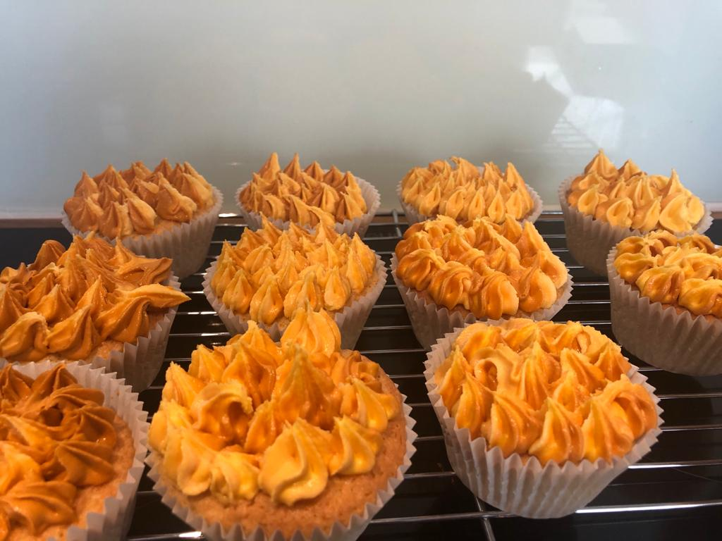
Pentecost Cupcakes

Cupcakes are great for teatime!
Have fun making these together.

Makes 12  12-hole muffin cake tin  100g (4oz) butter, softened  150g (5oz) self-raising flour  150g (5oz) caster sugar  3 tbsp milk  2 large eggs  ½ tsp vanilla extract  for butter icing  100g (4oz) butter, softened  225g (8oz) sifted icing sugar  ½ tsp vanilla extract  red, orange & yellow food colourings  piping bag | Step One  Preheat the oven to 180°C/Fan 160°C/gas 4. Put the muffin cases into the muffin tin, so that the cakes keep a good, even shape as they bake.  Step Two  Measure all the cupcake ingredients into a large bowl and beat until blended and smooth. Spoon evenly between the paper cases.  Step Three  Bake for 20-25 minutes or until risen and golden brown. Lift the paper cases out of the tin and cool the cakes on a wire rack until completely cold before icing.  Step Four  To make the butter icing, beat together the butter, icing sugar (and vanilla extract, if used) to give a creamy thick icing. To see how to colour your icing for the flames, see the video clip, which will be part of our YouTube service.

If you are making a double quantity of cupcakes or are using a smaller tin, you can prepare your cupcake mixture in one go and spoon it into the paper cases ready to go into the oven. They will come to no harm, as raising agents react more slowly nowadays. Bake only one tray of cupcakes at a time though.

